

ITA_User Instruction Manual

Role-based access control for

data records

*－*Version 1.9 *－*

Copyright © NEC Corporation 2021. All rights reserved.

Disclaimer

All the contents of this document are protected by copyright owned by NEC Corporation.

Unauthorized reproduction or copying of all or part of the contents of this document is prohibited.

The contents of this document are subject to change without prior notice in the future.

NEC Corporation is not responsible for any technical or editorial errors or omissions in this document.

NEC Corporation do not guarantee accuracy, usability, certainty of the content in this document.

Trademark

* Linux is registered trademark or trademark of　Linus Torvalds, registered in the U.S. and other countries.
* Red Hat is registered trademark or trademark of Red Hat, Inc. registered in the U.S. and other countries.
* Apache, Apache Tomcat, and Tomcat are registered trademarks or trademarks of the Apache Software Foundation.
* Ansible is registered trademark or trademark of Red Hat, Inc.

The names of other systems, company name and products mentioned in this document are registered trademarks or trademarks of their respective companies.

The ® mark and TM mark are not specified in this document.

※「Exastro IT Automation」 is written as 「ITA」 in this document.

**Table of contents­­**

Introduction 3

1 Overview of role-based access control for data records (RBAC). 4

2 Main functions of role-based access control (RBAC) 5

3 Role link for each user 6

3.1 Design roles to control access and register for role list 8

3.2 Role and menu registration in role/menu link list. 10

3.3 User (Accounts) with user list registration 11

3.4 Registration of link between user and role in the Role/User list 12

4 Role link for data 13

4.1 New data 18

4.2 Updating Data 22

4.2.1 Handling discarded roles 22

4.2.2 Handling roles no longer linked to users/roles 24

4.2.3 When specific data is shared by multiple roles 25

4.3 Data restoration 28

4.4 Data restore 28

4.5 Upload from Excel 28

4.6 Uploading from RestAPI 32

4.6.1 EDIT（X-Command） 32

5 Display restrictions for linked roles. 33

5.1 Display list 34

5.1.1 Login results for each user 35

5.2 Trace history 44

5.3 Display filter 49

5.4 RestAPI display filter 55

# Introduction

This document explains the functions and operation methods of the role-based access control for data records (RBAC).

# Overview of role-based access control for data records (RBAC).

Access for each data record can be controlled by assigning a role that allows access for each user and data record.

If the features above are not going to be used, please leave the default access permission roles blank.

In this document, "Role-based access control for data records (RBAC)" is hereinafter written as "Role-based access control　(RBAC)".

# Main functions of role-based access control (RBAC)

The main functions of role-based access control (RBAC) fall in the following categories.

* Web  
  Web content. A screen where you can use the menu creation function provided by the browser.
* BackYard  
  Resident process that runs on the server independently of the web contents.

# Role link for each user

To perform role-based access control (RBAC), set up roles that allow access permission for each user.

For example, we will explain the following procedure (chapter 3.1 ~ 3.4) based on the registration example in "Table 3-1".

Table 3-1 Chapters and registration example

|  |  |  |
| --- | --- | --- |
| **Chapter/**  **Section** | **「Management Console」menu group** | **Register example** |
| 3.1 | 「Role list」Menu | |  | | --- | | **Role** | | Role_A | | Role_B | |
| 3.2 | 「Role/Menu link list」Menu | |  |  |  | | --- | --- | --- | | **Role** | **Menu** | **Link** | | Role_A | Menu_A | Maintenance | | Role_B | Menu_A | Maintenance | | Role_B | Menu_B | Maintenance | |
| 3.3 | 「User list」Menu | |  | | --- | | **User** | | User_A | | User_B | |
| 3.4 | 「Role/User link list」Menu | |  |  |  | | --- | --- | --- | | **Role** | **User** | **Default access permission** | | Role_A | User_A | ● | | Role_B | User_B | ● | |
| -  ※ | 「Menu list」Menu | |  | | --- | | **Menu** | | Menu_A | | Menu_B | |

※For details about create menu, please refer to "ITA_User_Instruction_Manual_Menu_creation_function".

The above "Table 3-1" is mapping in the following relationship.

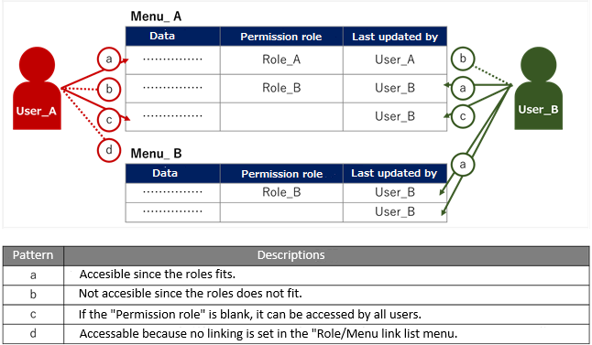

Figure 3- 1　Overall view

In the case of "Pattern: d" above, the following dialog will be displayed.

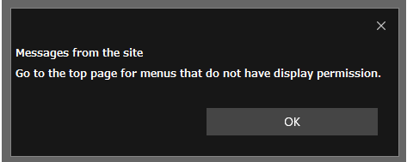

**Figure 3-2 Dialog displayed when display permission is not available**

For example, if "User_A" tries to access "Menu_B" which is not linked, the user will be redirected to the top page because he does not have permission to access the menu.

## Design roles to control access and register for role list

Design a role that is going to control access and register it from the "Management Console" menu group> "Role list" menu.

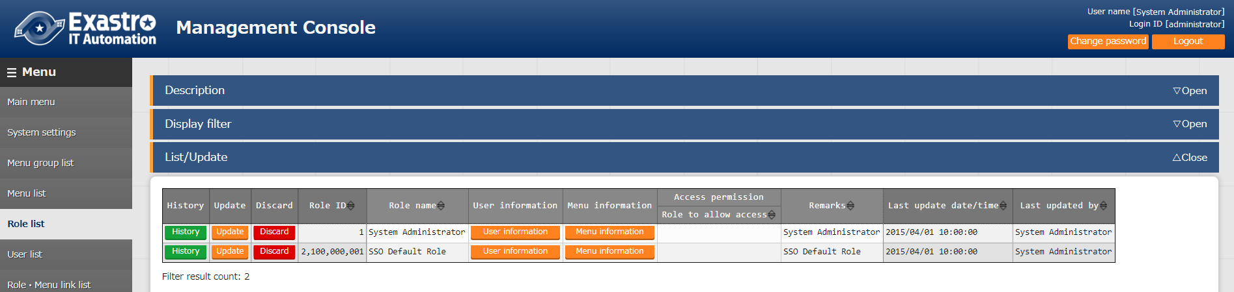

**Figure 3.1-1 "Management Console" Menu Group> "Role list" Menu**

* A role has two functions.

1. Menu access permissions

Access permission to each menu is registered from the "Management Console" Menu group > "Role/Menu link list" Menu.

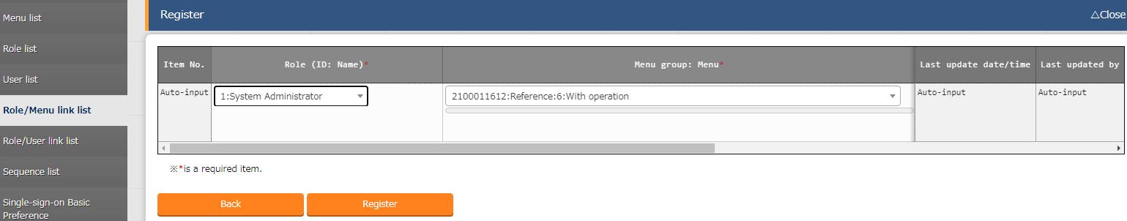

**Figure 3.1-1 "Management Console" Menu Group> "Role/Menu link list" Menu**

1. Roles for data records

Roles assigned to each user's data are registered from the "Management Console" Menu Group> "Role/User link list" Menu.

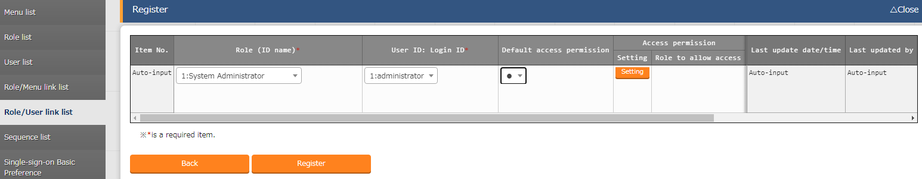

**Figure 3.1-2 "Management Console" Menu Group> "Role/User link list" Menu**

The following roles are registered when ITA is installed by default. Please do not change/update them.



**Figure 3.1-3 "Management Console" Menu Group> "Role list" Menu**

In addition, this document describes "(2) roles given for each data record" of the two roles. (In Figure 3-1, "Pattern: a, b, and c" is applicable.)

For "(1) Access permission to menus", please refer to "ITA_User_Instruction_Manual_Management Console." (In Figure 3-1, "Pattern: d" is applicable.)

## Role and menu registration in role/menu link list.

Register a link between each role and menu in the "Management Console" menu group > "Role/Menu link list".

Newly registered roles will be required to have it linked to each menu in the "Role/Menu link list" menu.

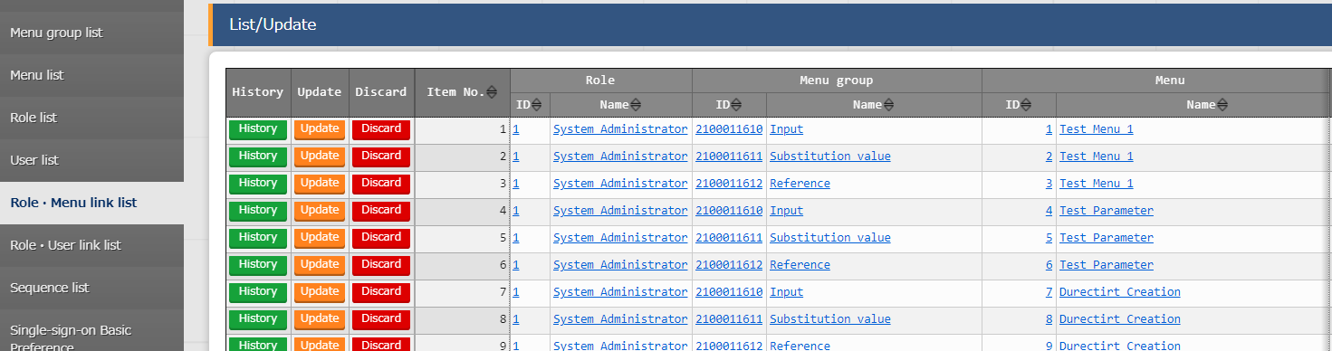

**Figure 3.2-1 "Management Console" Menu Group> "Role/Menu link list" Menu**

The "System Administrator (role)" is linked to all menus by default when installing ITA. Please do not change/update it.

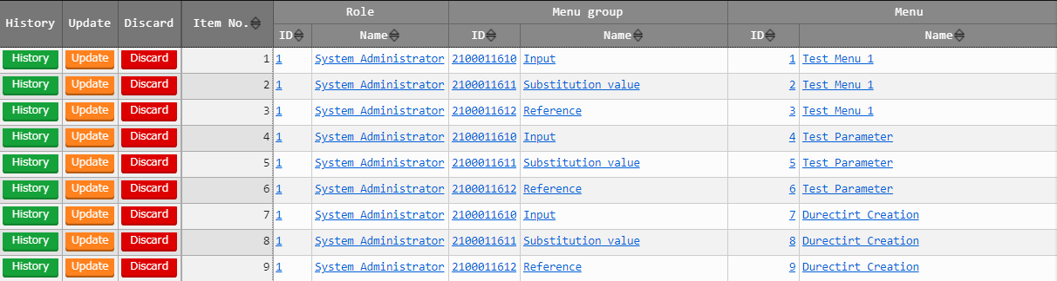

**Figure 3.2-2 "Management Console" Menu Group> "Role/Menu link list" Menu**

Assume that "Menu_A" and "Menu_B" are created.

For details about create manu, please refer to "ITA_User_Instruction_Manual_Menu_creation_function".

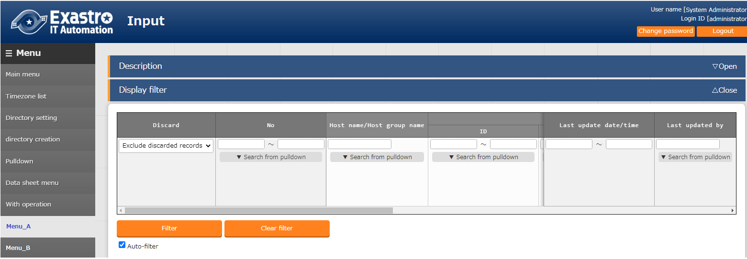

**Figure 3.2-3 "Input" Menu Group> "Menu_A" Menu**

## User (Accounts) with user list registration

Register a user (Account) from the "Management Console" menu group > "User list" menu.

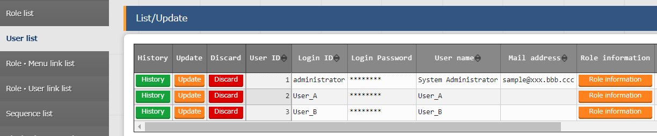

**Figure 3.3-1 "Management Console" Menu Group> "User list" Menu**

The following users (accounts) are registered by default when installing ITA. Please do not change/update them.



**Figure 3.3-2 "Management Console" Menu Group> "User list" Menu**

## Registration of link between user and role in the Role/User list

Register the user-role link "Management Console" menu group > "Role/User link list" menu.

When registering new data, if you specify it as the default role to be granted to the data, the setting is performed in the "Default access permission" column.

By setting "●" in the "Default access permission" column, it will be a role (Permission role) set as the default when registering new data.

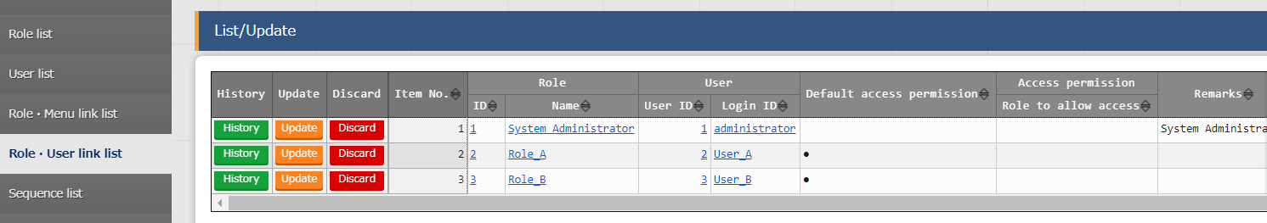

**Figure 3.4-1 "Management Console" Menu Group> "Role/User link list" Menu**

If RBAC is not going to be implemented, please leave the "Default access permission" field blank.

The following user/role link will be registered by default when installing ITA. Please do not change/update them.



**Figure 3.4-2 "Management Console" Menu Group> "Role/User link list" Menu**

# Role link for data

In the following explanation, assumes that “Table 4-1” will be set below.

Table 4-1 Menu and registration example

|  |  |  |
| --- | --- | --- |
| **No.** | **Menu** | **Registration example** |
| **1** | 「Management Console」Menu group>  「Role list」menu | System Administrator, Manager_Company_A, Company_A_KANTO, Company_A_KANSAI, Manager_Company_B, Company_B_KANTO, Company_B_KANSAI, |
| **2** | 「Management Console」Menu group>  「User list」menu | |  |  | | --- | --- | | **Login ID** | **User name** | | administrator | System administrator | | A_admin | Admin_Company_A | | A_user01 | Company_A_user01 | | A_user02 | Company_A_user02 | | A_user03 | Company_A_user03 | | B_admin | Admin_Company_B | | B_user01 | Company_B_user01 | | B_user02 | Company_B_user02 | | B_user03 | Company_B_user03 | |
| **3** | 「Management Console」Menu group>  「Role/User link list」menu | |  |  | | --- | --- | | **ロール** | **User name** | | System Administrator | System Administrator | | Manager_Company_A | System Administrator, Admin_Company_A (●) | | Company_A_KANTO | System Administrator, Admin_Company_A,  Company_A_user01 (●), Company_A_user03 | | Company_A_KANSAI | System Administrator, Admin_Company_A,  Company_A_user02 (●), Company_A_user03 | | Manager_Company_B | System Administrator, Admin_Company_B (●) | | Company_B_KANTO | System Administrator, Admin_Company_B,  Company_B_user01 (●), Company_B_user03 | | Company_B_KANSAI, | System Administrator, Admin_Company_B,  Company_B_user02 (●), Company_B_user03 |   ●…Default access permission |
| **4** | 「Management Console」Menu group>  「Menu list」menu | 「Basic Console」Menu group >「Operation list」menu |
| 「Management Console」Menu group>  「Role/Menu link list」menu | |  |  | | --- | --- | | **Role** | **Menu** | | System Administrator, Manager_Company_A, Company_A_KANTO, Company_A_KANSAI, Manager_Company_B, Company_B_KANTO, Company_B_KANSAI, | 「Basic Console」Menu group >  「Operation list | |

* 1. "Role list" menu reflecting the registration example in "Table 4-1"

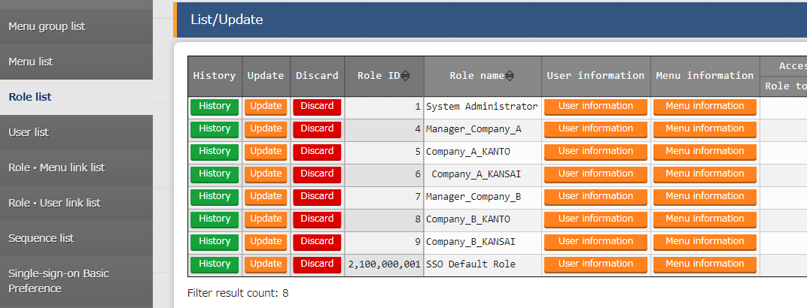

**Figure 4-1 “Management Console” menu group > ”Role list menu”**

1. "User list" menu reflecting the registration example in "Table 4-1"

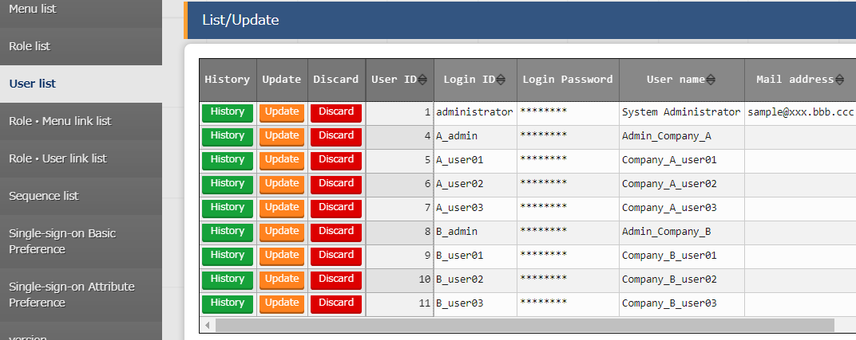

**Figure 4-2 "Management Console" Menu group > "User list" Menu**

1. "Role/User link list" menu reflecting the registration example in "Table 4-1"

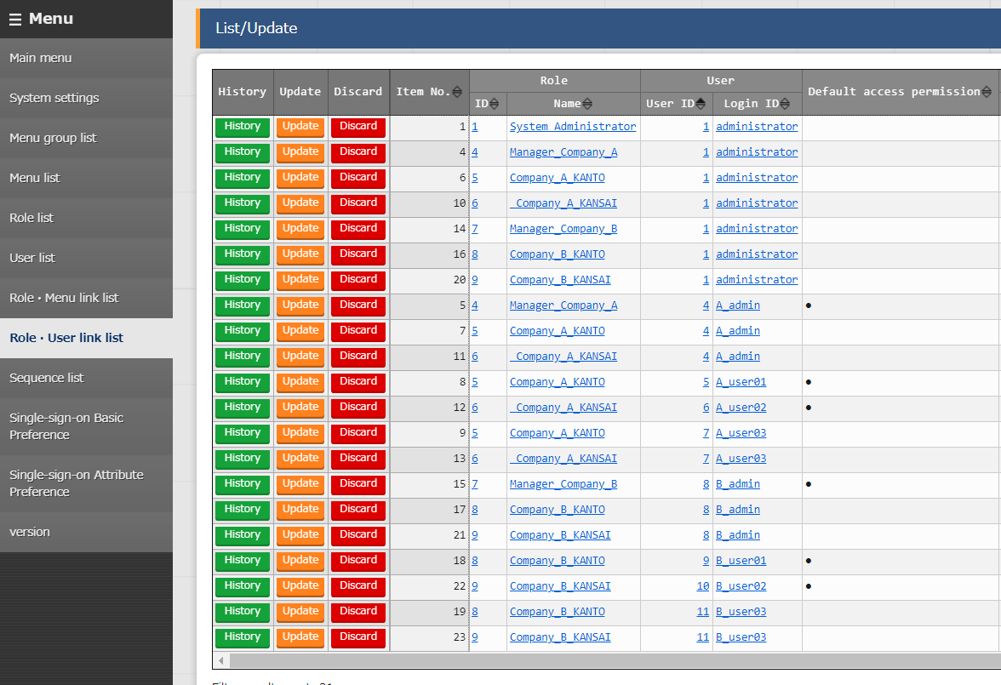

**Figure 4-3 "Management Console" Menu group > "Role/User link list" Menu**

Table 4-2 List of Settings for "Role/User link list"

|  |  |  |  |  |  |  |  |
| --- | --- | --- | --- | --- | --- | --- | --- |
| **Role name**  **User name**  （Login ID） | **System administrator** | **Manager_Company_A** | **Company_A_KANTO** | **Company_A_KANSAI** | **Manager_Company_B** | **Company_B_KANTO** | **Company_B_KANSAI** |
| **System Administrator**  （administrator） | 〇 | 〇 | 〇 | 〇 | 〇 | 〇 | 〇 |
| **Manager_Company_A**（A_admin） |  | ● | 〇 | 〇 |  |  |  |
| **Company_A_user01**（A_user01） |  |  | ● |  |  |  |  |
| **Company_A_user02**（A_user02） |  |  |  | ● |  |  |  |
| **Company_A_user03**（A_user03） |  |  | 〇 | 〇 |  |  |  |
| **Manager_Company_B**（B_admin） |  |  |  |  | ● | 〇 | 〇 |
| **Company_B_user01**（B_user01） |  |  |  |  |  | ● |  |
| **Company_B_user02**（B_user02） |  |  |  |  |  |  | ● |
| **Company_B_user03**（B_user03） |  |  |  |  |  | ● | ● |

●:　 With link in Role/User link list. Set "●" with default access permission

〇:　 With link in Role/User link list. Set the "Default access permission" to be blank.

1. "Role/Menu link list" menu reflecting the registration example in "Table 4-1"

New roles needs to be linked to a menu. This can be done in "Role/Menu link list" menu.

The following assumes that each role is getting linked to "Basic Console" menu group > "Operation list" menu.

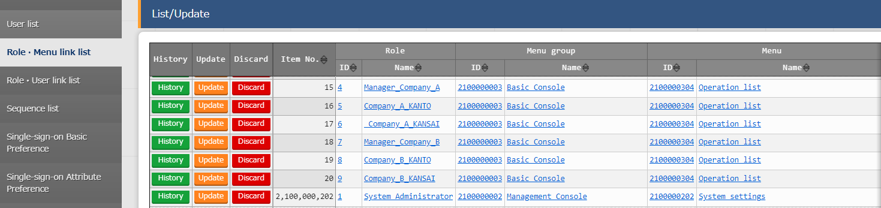

**Figure 4-4 "Management Console" Menu group > "Role/Menu link list" Menu**

Example) If user "B_admin" is logged in

By linking, user "B_admin" can access the "Operation list" menu > "Basic Console" menu group.

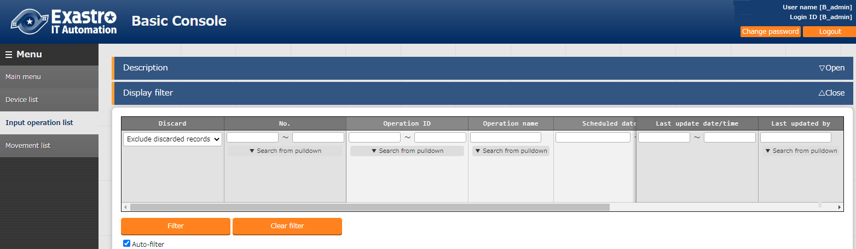

**Figure 4-5 "Management Console" Menu group > "Input operation" Menu**

## New data

It is possible to set "access permissions" for data when registering it.

The following figure 4.1-1,"Basic Console" menu group > "Operation list" shows the data registration sub menu (operation).

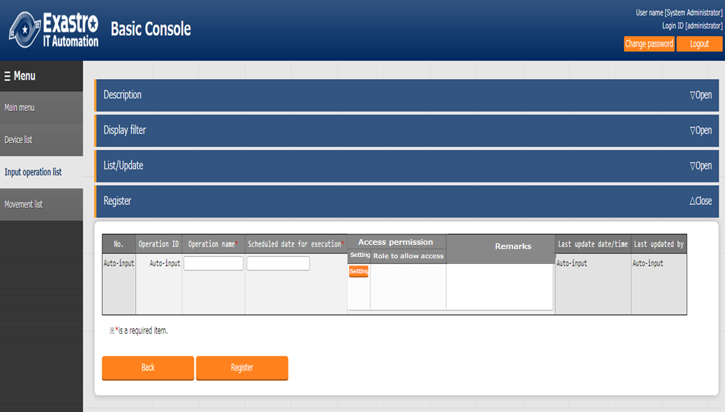

**A**

**B**

**Figure 4-5 "Basic Console" Menu group > "Operation list" Menu**

1. “Role to allow access” column.  
   The role that grants access to data records will be displayed.  
   The default permission access role will be displayed in the "Permission role" column.

If no default permission access role is set, it will be blank.

Only the user linked with the permission role can view/change the data.  
If the permission role is blank, all users can view/change the data.

If Role-based access control (RBAC) is not getting implemented, do not set any permission roles.

※1　 Default Permission roles

Roles with "●" selected in the "Default permissions" column of the "Role/User link list" menu will have their role name displayed in the "permission role" column when registering by default.

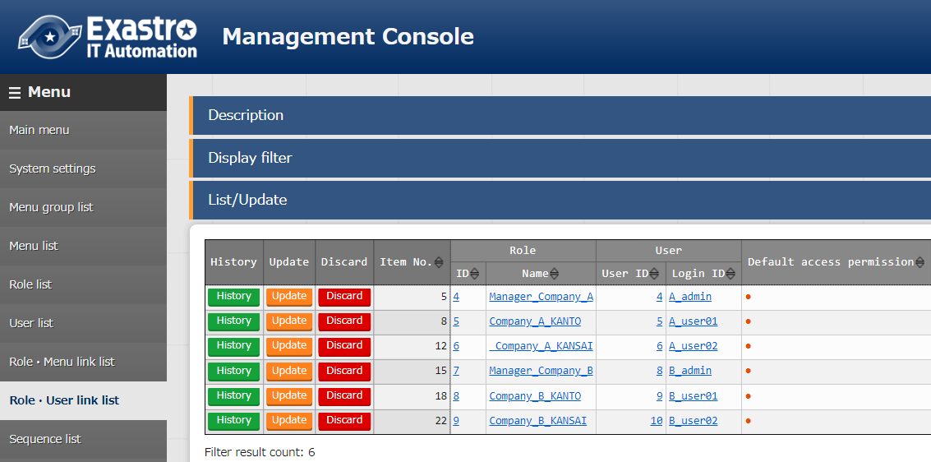

**Figure 4.1-2 "Management Console" Menu group > "Role/User link list" Menu**

Example）If user "A_user03" is logged in.

User "A_user03" is not set to "Default permissions", so by default, nothing will be displayed in the "Permission role" column when registering.

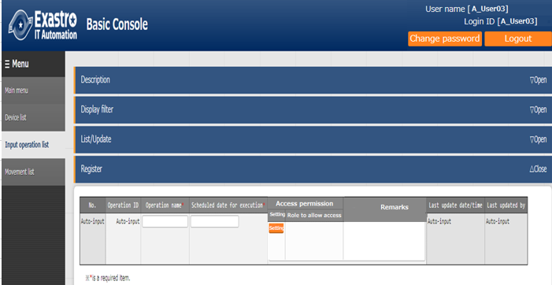

**Figure 4.1-3 "Basic Console" Menu group > "Operation list" Menu**

Example）If "B_user02" is logged in.

Since User "B_user02" is set to "Default permissions", the role set to it will be displayed in the "permission role" column by default when registering.

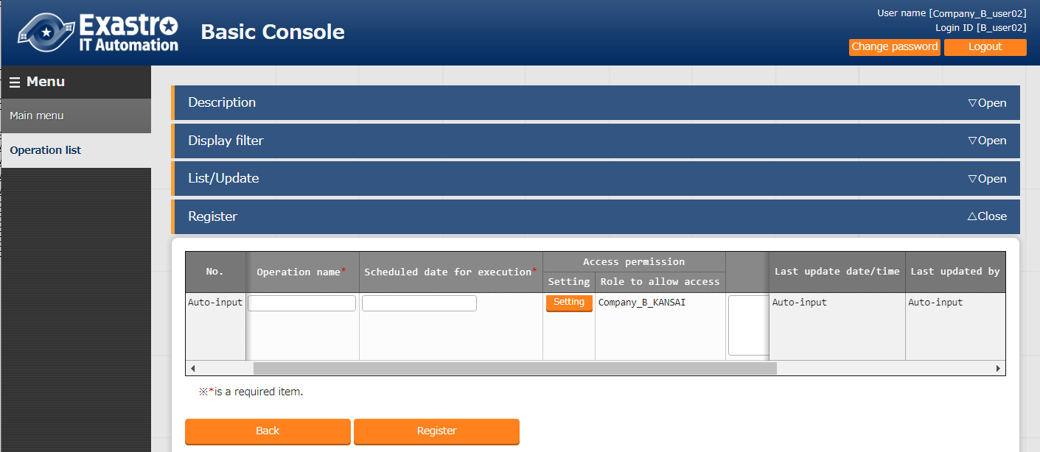

**Figure 4.1-4 "Basic Console" Menu group > "Operation list" Menu**

1. 「Settings」column  
   If you want to change the permission role, click the "Setting" button.  
   A dialog box where users can change permission role will be displayed.

The dialog box displays a list of roles linked to the user from the user in the "Role/User link list" menu.  
Select permission role then press the "Decision" button

The selected role will be mirrored "Permission role" column.  
If the "Decision" button is clicked without any role selected, the "Permission role" field will be left blank

If the "Permission role" is blank, the data can be viewed/changed by all users.

Clicking the "register" button will register all the contents displayed in the "permission role" column.

Example）If user "A_user03" is logged in.

The roles linked to user “A_user03”, “Company_A_KANTO” and “Company_A_KANSAI” will be displayed in a dialog box

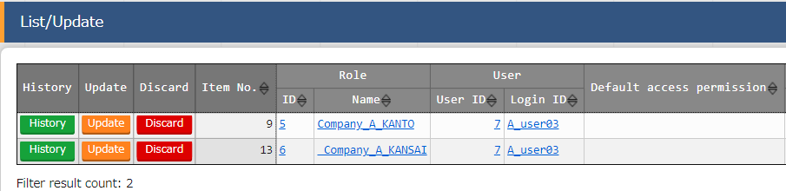

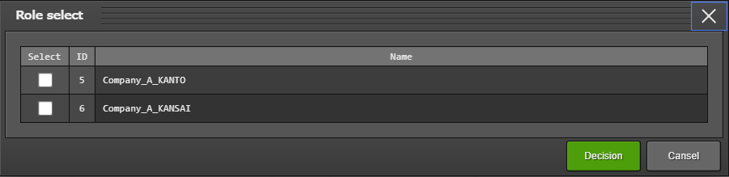

**Figure 4.1-5 Changing permission role dialog**

## Updating Data

Roles that grants permission to data records will be displayed in the "Permission role" column.

Change the permission role as needed.

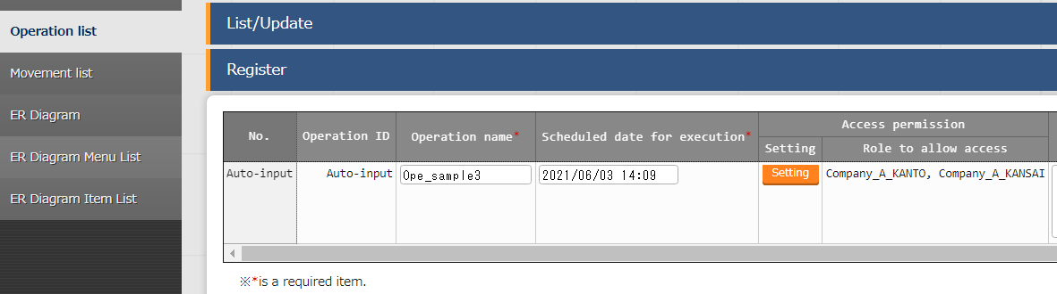

**Figure 4.2-1 "Basic Console" Menu group > "Input operation" Menu**



### Handling discarded roles

If a role is abolished in "Basic Console" Menu group > "Role list" Menu, it will be display in "Permission role" column as "ID conversion failure".

Example）If Role "A_user01" is abolished,

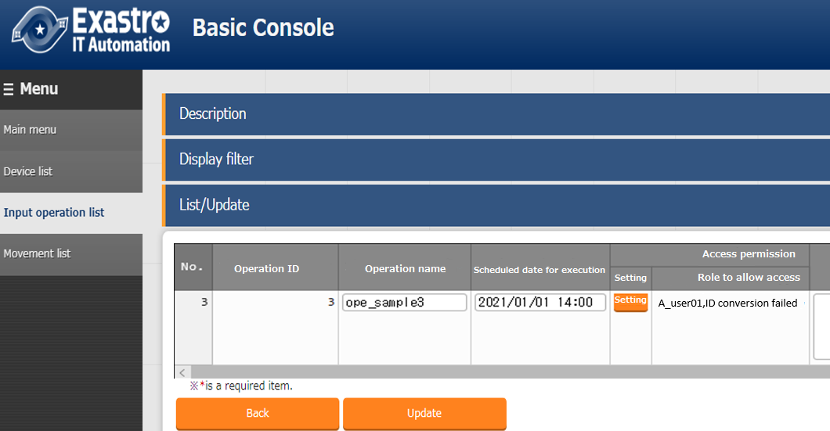

**Figure 4.2-2 "Basic Console" Menu group > "Input operation" Menu**

If the "update" button is clicked when the screen is the same as "Figure 4.2-2", Abolished roles will be deleted from the column. (In this case, (ID Conversion Failure) disappears and only A_user01 will be displayed).

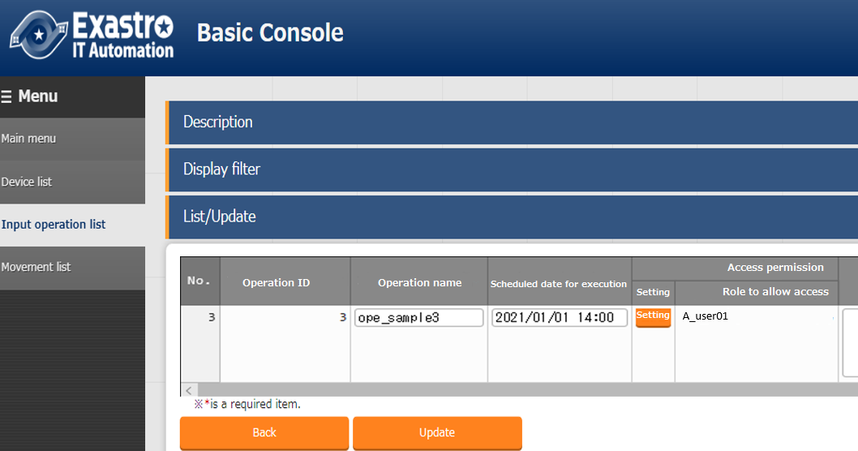

**Figure 4.2-3 "Basic Console" Menu group > "Input operation" Menu**

Unless the "Update" button in the "List/Update" sub menu is pressed, any abolished roles will remain in the "Permission role" and will be displayed as "ID conversion failure".

### Handling roles no longer linked to users/roles

If a role link is abolished in the "Management Console" menu group > "Role/User list" menu, the abolished role will be displayed as ****** in the "Permission Role" column.

example）Abolishing the link between "B_user03" and "Company_B_KANSAI" and logging in as User "B_user03".

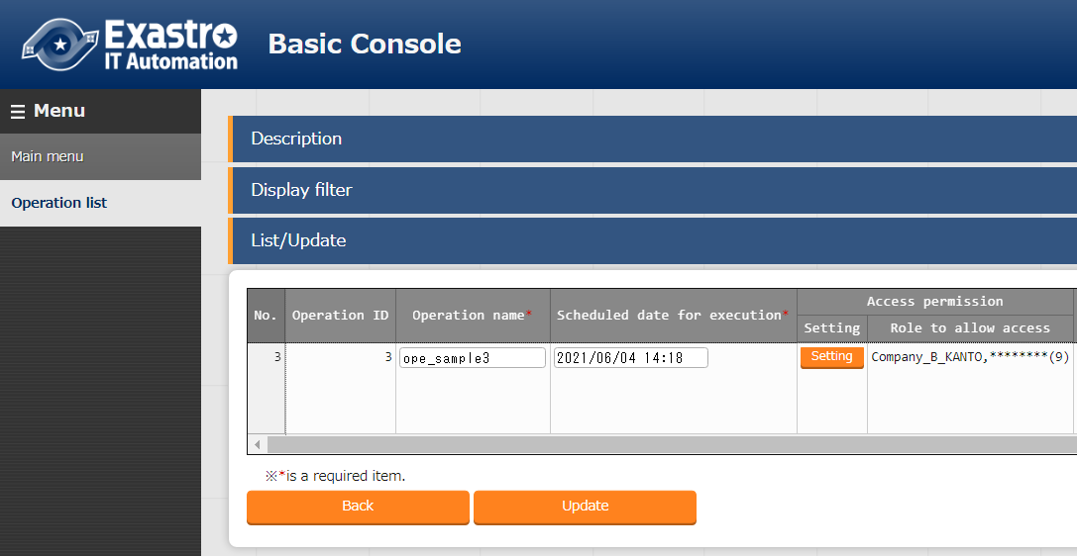

**Figure 4.2-3 "Basic Console" Menu group > "Input operation" Menu**

The "Permission role" column will not change even if the update button is clicked when the screen is the same as Figure "Figure 4.2-3".

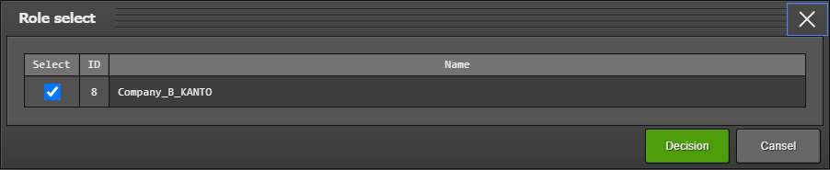If you want to remove the "********" display from the "Permission role" column, press the "Setting" button on the "List/Update" sub menu to display the dialog and press the "Decision" button.

**Figure 4.2-4 "Role select" Screen**

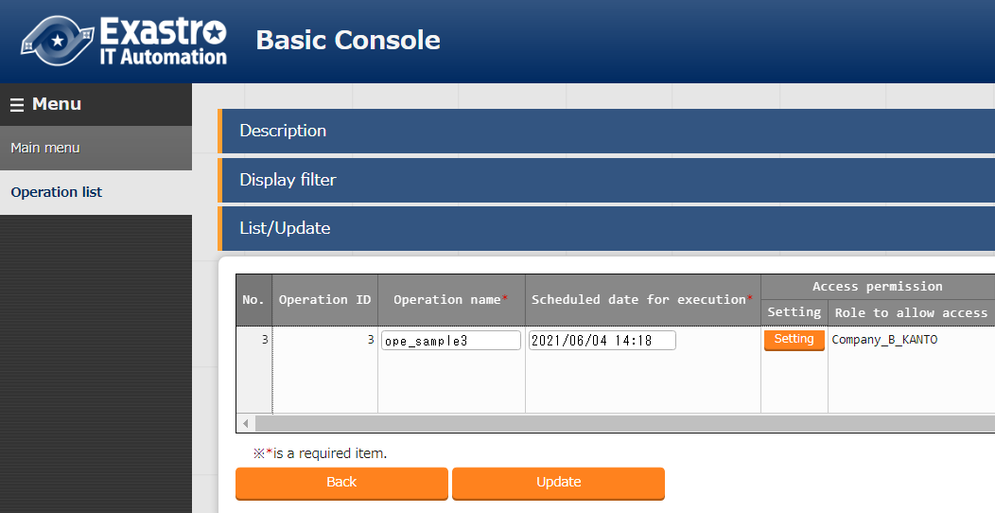

**Figure 4.2-5 "Basic Console" Menu group > "Input operation" Menu**

Unless you press the "Decision" button on the dialog, abolished role will remain in the "Permission role" column with the display "********".

### When specific data is shared by multiple roles

If data has multiple permission roles registered for it, roles without a link from the "Role/User link list" menu will be displayed as "*******" in the "Permission role" column.

Example）Logging in as B_user03 and registering data in the "Permission role" column in the default state.

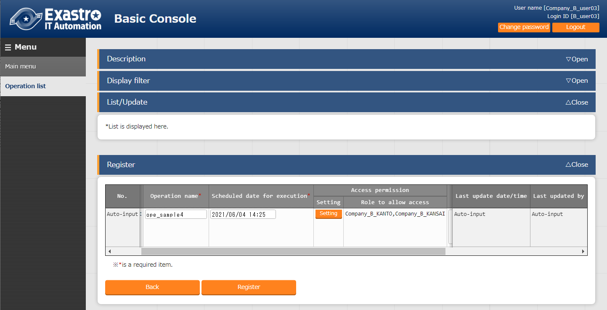

**Figure 4.2-6 "Basic Console" Menu group > "Input operation" Menu**

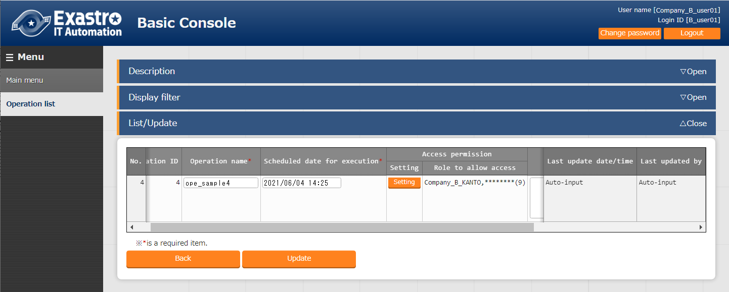 Log in as user "B_user01".User "B_user01" is not linked to the role "B_user02". Roles that are not linked will be displayed as "********" in the Permission role display.

**Figure 4.2-7 "Basic Console" Menu group > "Input operation" Menu**

The permission role column will not change even if the update button is clicked when the screen is the same as Figure "Figure 4.2-7".

If you want to remove the "********" from the "Permission role" column, press the "Setting" button to display the dialog and press the "Decision" button.

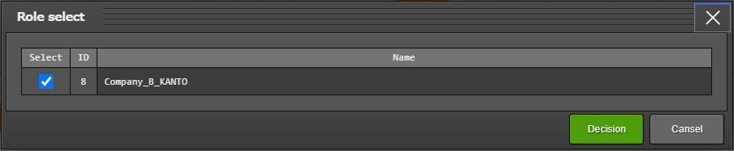

**Figure 4.2-8 "Role select" Screen**

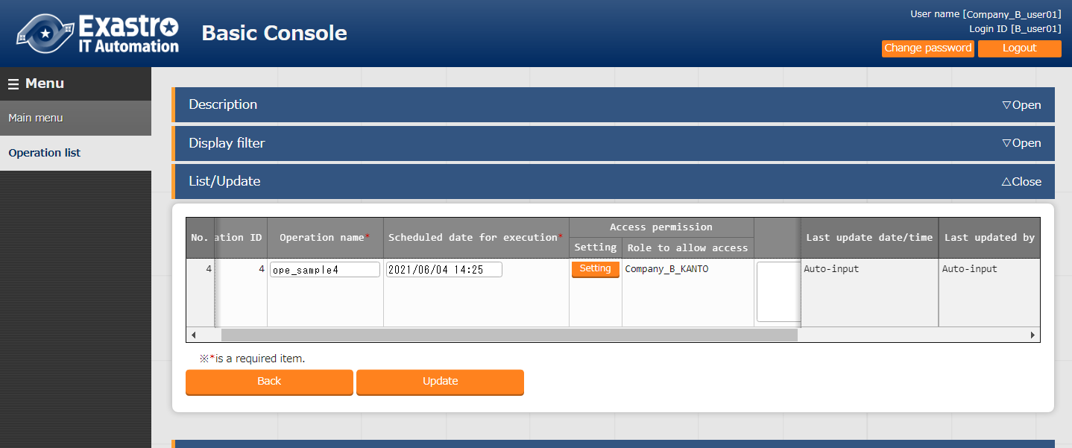

**Figure 4.2-9 "Basic Console" Menu group > "Input operation" Menu**

Unless you press the "Decision" button on the dialog, the abolished role will remain in the "Permission role" column with the display "********".

## Data restoration

Abolishing the data will not change the permission role.

## Data restore

Restoring the data will not change the permission role.

## Upload from Excel

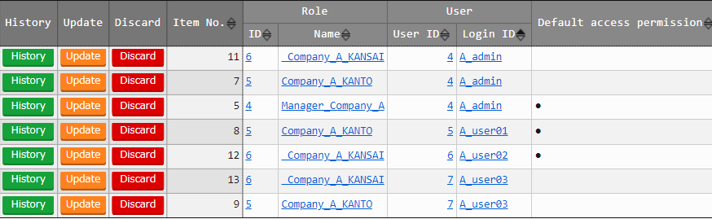The following information registered based on "Table 4-1" is used to explain the information below.

**Figure 4.5-1 "Basic Console" Menu group > "Role/User link list" Menu**

If an excel file is downloaded from the button below, the user's default permission role will be displayed in the "Permission role" column in the blank row of the downloaded Excel.

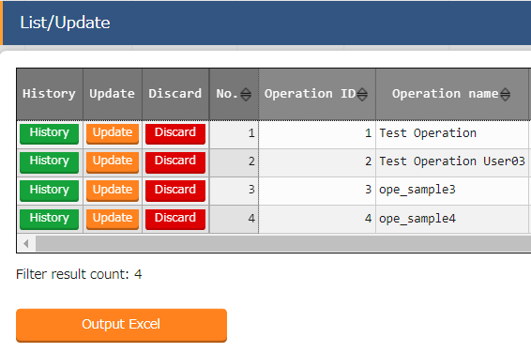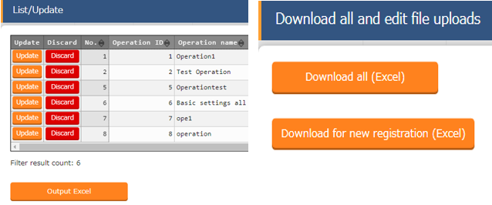

**Figure 4.5-2 "Basic Console" Menu group > "Input operation" Menu**

Example）If user is logged in as user "A_admin" and downloads the excel file. 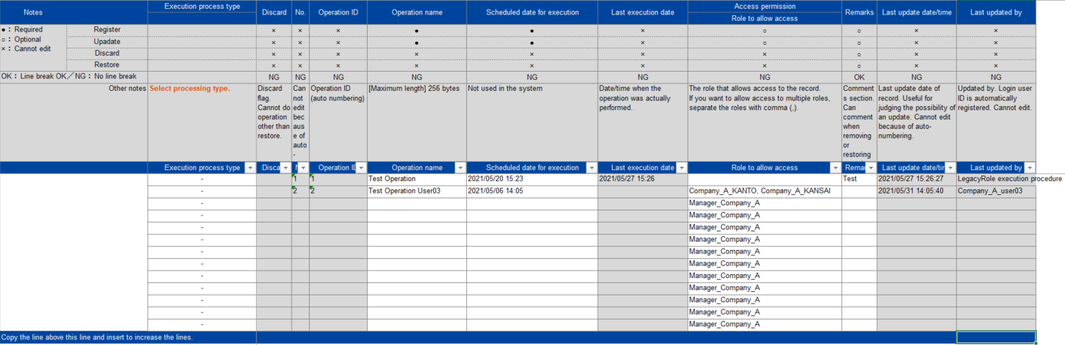

**Figure 4.5-3 Download from "Excel Output" button > "List/Update" sub menu**

If you're uploading from Excel, make sure that the "Permitted Roles" column has a role set that is within the range of roles linked to the "Management Console" menu group > "Role/User link list" menu.

If you want to set multiple roles, separate them with commas.

Example) Example: Setting within the scope of the role linked with the user

**Table 4.5-1 List of "Figure 4.5-1"**

|  |  |
| --- | --- |
| **Login user** | **Configuration value of permission role** |
| A_admin | Manager_Company_A, Company_A_KANTO, Company_A_KANSAI |
| A_user01 | Company_A_KANTO |
| A_user02 | Company_A_KANSAI |
| A_user03 | Company_A_KANTO, Company_A_KANSAI |

1. Register

Example) If logged in as user "A_admin" and downloaded to excel.

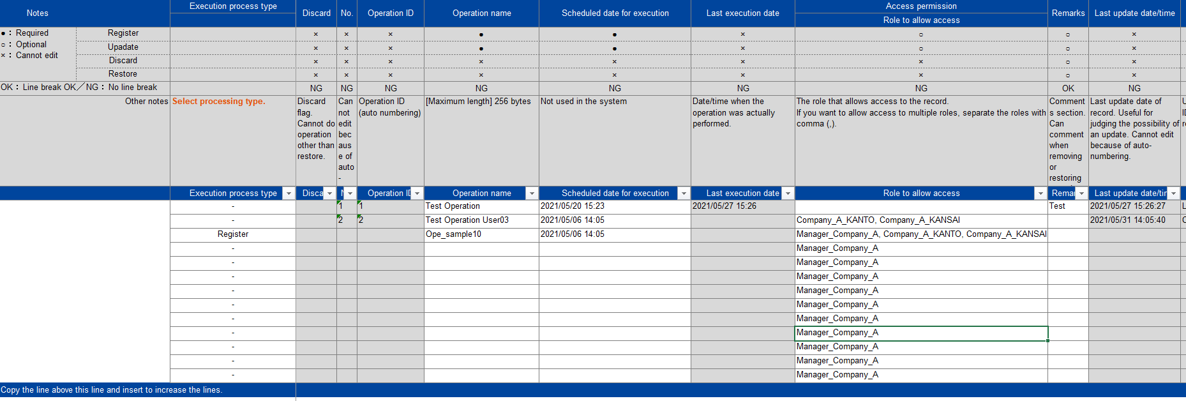Enter the required information as shown in the red frame in the figure below.

**Figure 4.5-4 Output updated excel**

When you upload the updated Excel (Fig. 4.5-4) from the "File upload" button of the "Basic Console" menu group> "Operation list" menu> "Download all and edit file upload" submenu, the data will be registered and added to the "List/Update" sub menu.

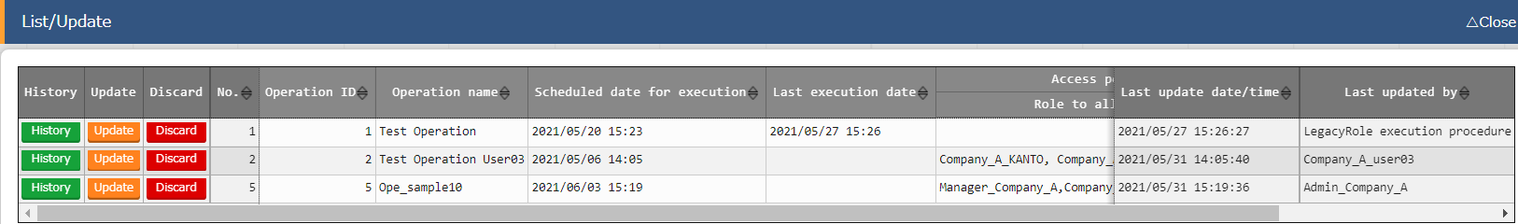

**Figure 4.5-5 Results of uploading the updated Excel**

1. Update

Set the role within the permission role set in the update record, but If you want to share data with multiple users and want to keep the role not associated with the login user, please set the role name as ***** (Role ID).

Example）If you want to leave a role that is not linked to a login user

**Table 4.5-2 Configuring permission roles for update records**

|  |  |
| --- | --- |
| **Login user** | **Access permission role setting value** |
| A_admin | Manager_Company_A, Company_A_KANTO, Company_A_KANSAI |
| A_user01 | ********(2), Company_A_KANTO, ********(4) |
| A_user02 | ********(2), ********(3), Company_A_KANSAI |
| A_user03 | ********(2), Company_A_KANTO, Company_A_KANSAI |

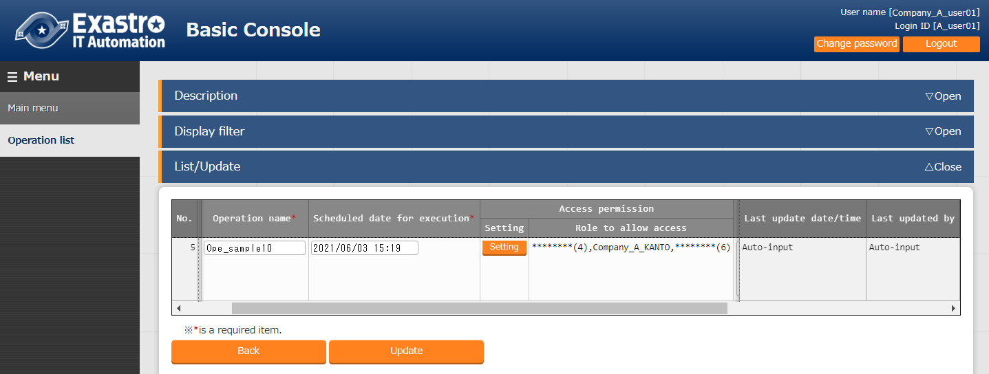

**Figure 4.5-6 List/Update sub menu when login "A_user01"**

1. Abolition/Revival

Aolbiting/reviving will not change the permission role.

If the permission role is blank, all users can view/change the data (When uploading from Excel, the permission role is automatically specified ※Figure 4.5-3).

If role based access control (RBAC) is not input, do not set the permission role.

## Uploading from RestAPI

Uploads from RestAPI (Registration, update, abolition,revival) are similar to "4.5 Upload from Excel".

However, Unlike uploading from Excel, "Permission role" is not specified by default.

**Table 4.6-1 Differences in default values by upload source**

|  |  |  |
| --- | --- | --- |
| **Upload source** | **Default value** | **Result when registered with default values** |
| Excel | The default permission role for the logged in user is specified. (Figure 4.5-3). | Only users with the specified role can see the data. |
| RestAPI | Unspecified | Data can be reference to all users |

When uploading from RestAPI, "Unspecified permission role" is the default.

If the "Permission Role" column is blank, all users can view/change the data, so please be careful if there is data that you do not want to view/change from other than a specific role.

If you want to narrow down the number of users who view/change data, please upload the permission role after specifying it.

If Role-based access control (RBAC) is not getting implemented, do not set any permission roles.



### EDIT（X-Command）

For details on how to operate from RestAPI, please refer to "ITA_User_Instruction_Manual_RestAPI ".

※"FILTER (X-Command)" will be described in "5.4 RestAPI display filter".

If you want to register or update data from RestAPI, set the access permission role to be within the range of roles linked with the user in the "Management Console" menu group > "Role/User link list" menu.

If you want to set multiple roles, separate them with commas.

If permission role field is blank, all users can view/change the data.

If Role-based access control (RBAC) is not getting implemented, do not set any permission roles.

# Display restrictions for linked roles.

This and any subsequent chapters assumes that the following data has been registered in the “Basic Console” menu group -> “Operation list” menu.

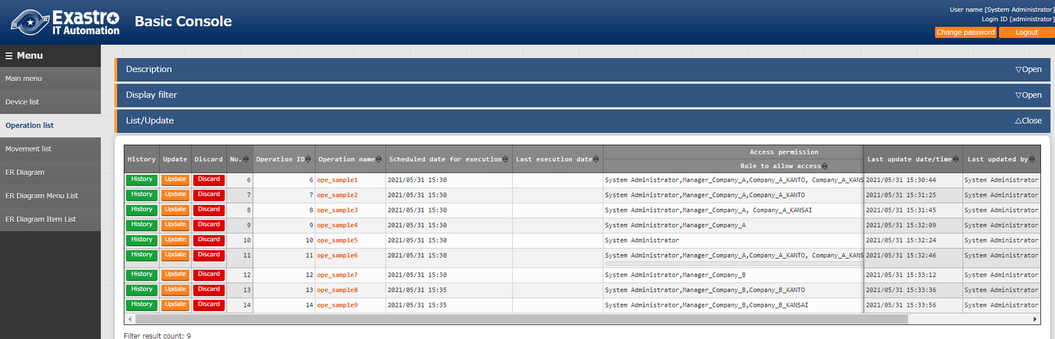

**Figure 5-1 "Basic Console" Menu group > "Input operation" Menu"**

**Operation name**

|  |  |  |  |  |  |  |  |  |  |
| --- | --- | --- | --- | --- | --- | --- | --- | --- | --- |
|  | ope_  sample1 | ope_  sample2 | ope_  sample3 | ope_  sample4 | ope_  sample5 | ope_  sample6 | ope_  sample7 | ope_  sample8 | ope_  sample9 |
| **System Administrator**  **User name**（Login ID）  （administrator） | ◆ | ◆ | ◆ | ◆ | ◆ | ◆ | ◆ | ◆ | ◆ |
| **Manager_Company_A**  （A_admin） | ◆ | ◆ | ◆ | ◆ |  | ◆ |  |  |  |
| **Company_A_user01**  （A_user01） | ◆ | ◆ |  |  |  | ◆ |  |  |  |
| **Company_A_user02**  （A_user02） | ◆ |  | ◆ |  |  | ◆ |  |  |  |
| **Company_A_user03**  （A_user03） | ◆ | ◆ | ◆ |  |  | ◆ |  |  |  |
| **Manager_Company_B**  （B_admin） |  |  |  |  |  | ◆ | ◆ | ◆ | ◆ |
| **Company_B_user01**  （B_user01） |  |  |  |  |  | ◆ |  | ◆ |  |
| **Company_B_user02**  （B_user02） |  |  |  |  |  | ◆ |  |  | ◆ |
| **Company_B_user03**  （B_user03） |  |  |  |  |  | ◆ |  | ◆ | ◆ |

Table 5- Data list displayed per user

◆：Data to be displayed by each user

## Display list

The data displayed in the "List/Update" submenu will be the data that has been assigned to the access permission role by the role linked with the user in the "Management Console" menu group > "Role/User Association Management" menu.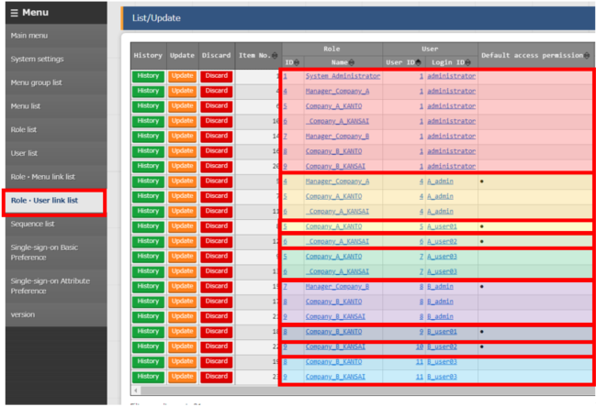

**Figure 5.1-1 "Role/User link list" menu reflecting "Table 4-1"**



### Login results for each user

* + - **User name： System Administrator** （Login ID：administrator）

If the user is logged in as "Administrator", the following data will be display in the "Basic Console" menu group > "Operation list" menu.

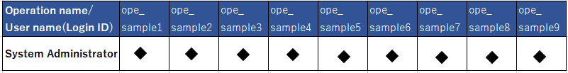

**Table 5.1-1 “Table 5-1”Extract**

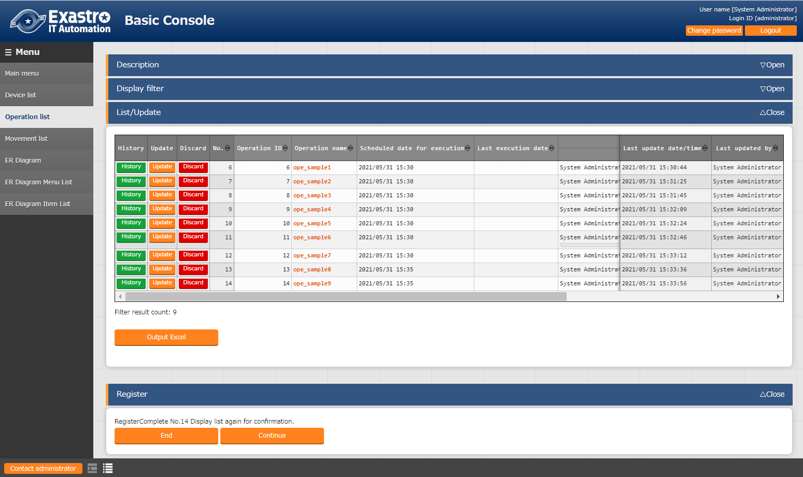

**Figure 5.1-2 List/Update sub menu when logged in as "administrator"**

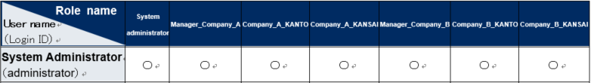The link between user "administrator" and each role is as follows. (Excerpted from Table 4-1）.

**Table 5.1-2 "Table 4-1" Excerpt**

* + - **User name: Manager_Company_A**(User ID：A_admin）

If the user is logged in as "A_admin", the following data will be displayed in the "Basic Console" menu group > "Operation list" menu.

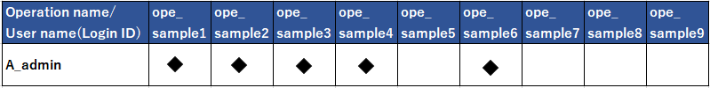

**Table 5.1-3 "Table 5-1" Excerpt**

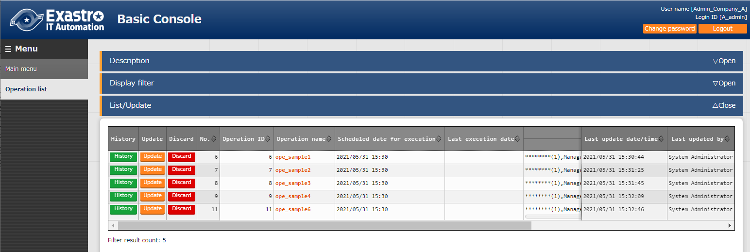

**Figure　5.1-3 List/Update sub menu when logged in as "A_admin"**

The link between user "A_admin" and each role is as follows. (Excerpted from Table 4-1）.

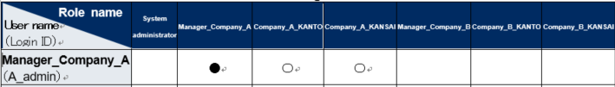

**Table 5.1-4 "Table 4-1" Excerpt**

* + - **User name： Company_A_user01**（User ID：A_user01）

If the user is logged in as "A_user01", the following data will be displayed in the "Basic Console" menu group > "Operation list" menu.

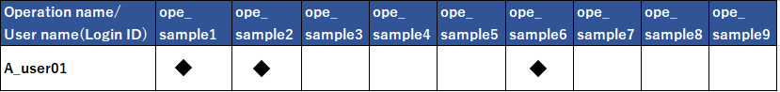

**Table 5.1-5 "Table 5-1" Excerpt**

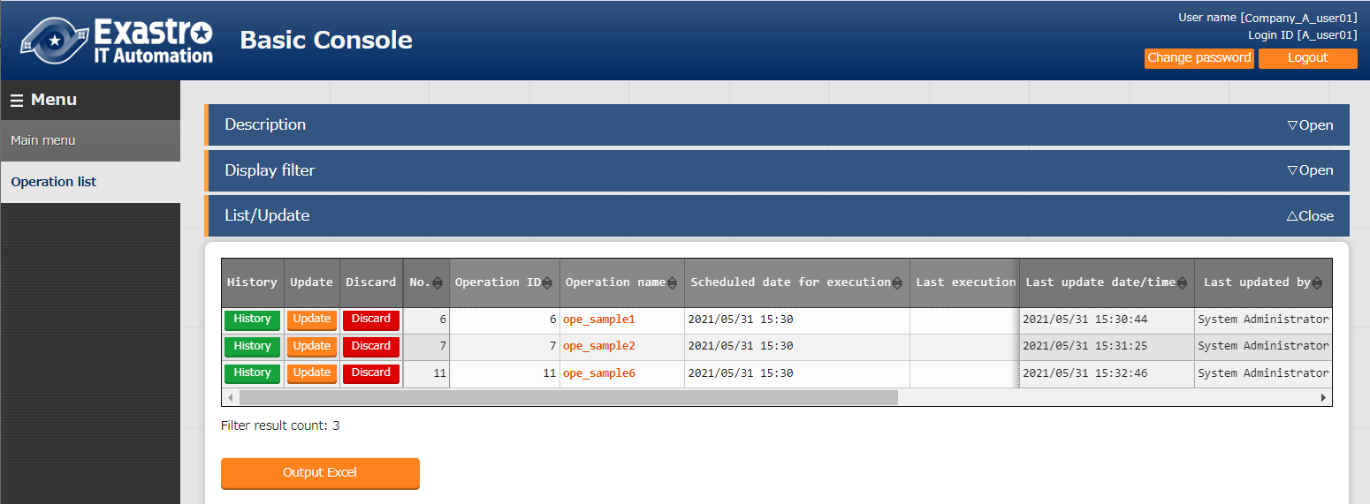

**Figure 5.1-4** **List/Update sub menu** **when logged in as "A_user01"**

The link between user "A_user01" and each role is as follows. (Excerpted from Table 4-1）.

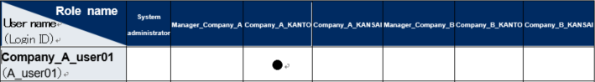

**Table 5.1-6 "Table 4-1" Excerpt**

* + - **User name：Company_A_user02**（User ID：A_user02）

If the user is logged in as "A_user02", the following data will be displayed in the "Basic Console" menu group > "Operation list" menu.

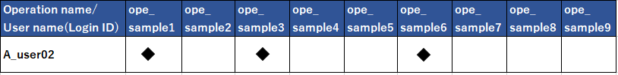

**Table 5.1-7 "Table 4-1" Excerpt**

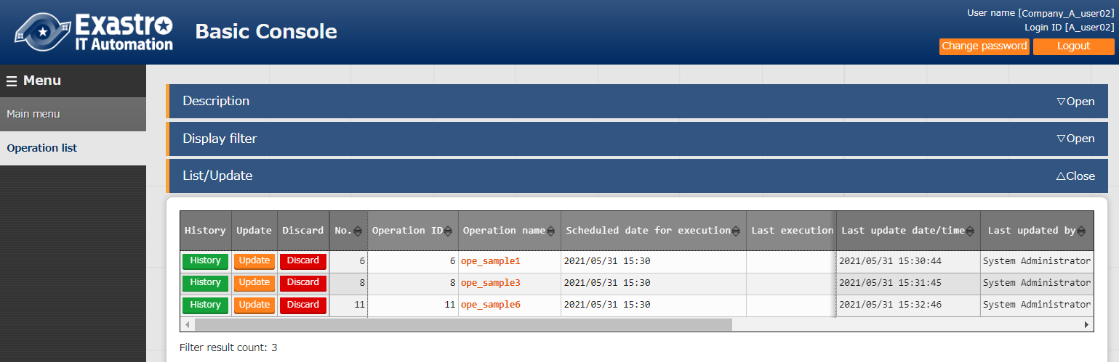

**Figure　5.1-5 List/Update sub menu when logged in as “A_user02”**

The link between user "A_user02" and each role is as follows. (Excerpted from Table 4-1）

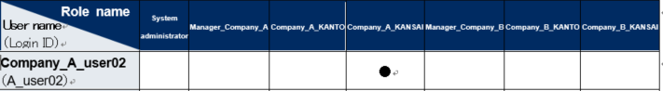

**Table 5.1-8 "Table 4-1" Excerpt**

* + - **User name：Company_A_user03**（User ID：A_user03）

If the user is logged in as "A_user03", the following data will be displayed in the "Basic Console" menu group > "Operation list" menu.

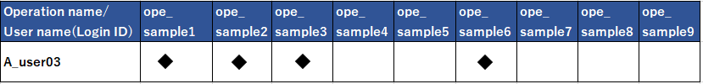

**Table 5.1-9 "Table 5-1" Excerpt**

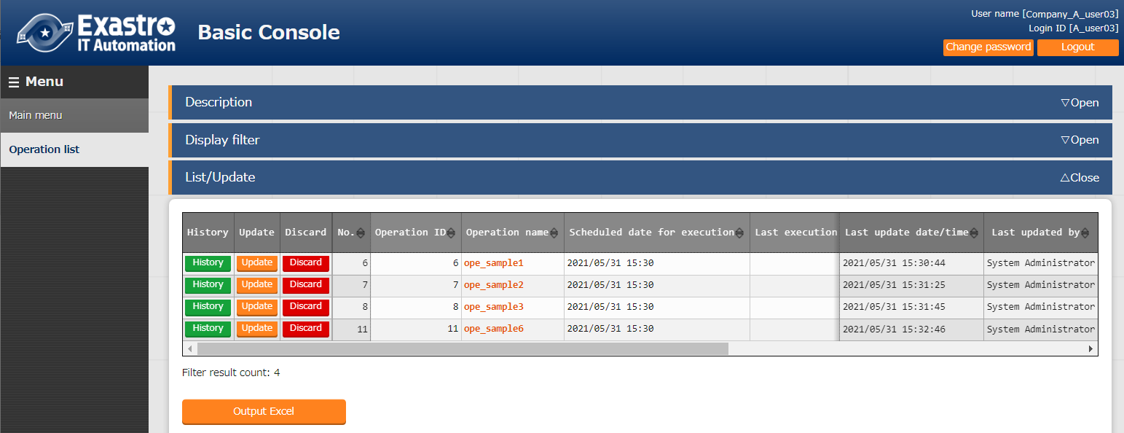

**Figure　5.1-6 List/Update sub menu when logged in as “A_user03”**

The link between user "A_user03" and each role is as follows. (Excerpted from Table 4-1）

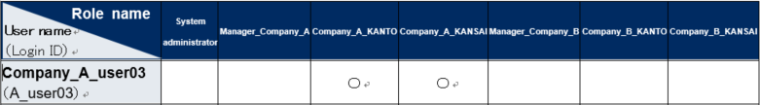

**Table 5.1-10 "Table 4-1" Excerpt**

* + - **User name： Admin_Company_B**（User ID：B_admin）

If the user is logged in as "B_admin", the following data will be displayed in the "Basic Console" menu group > "Operation list" menu.

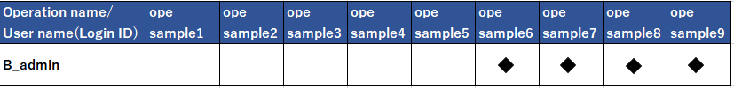

**Table 5.1-11 "Table 5-1" Excerpt**

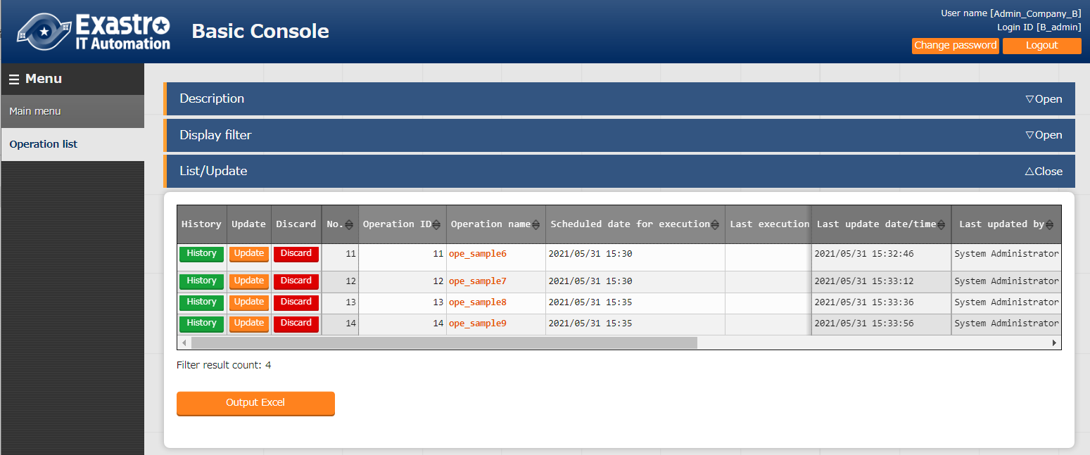

**Figure　5.1-7 List/Update sub menu when logged in as “B_admin”**

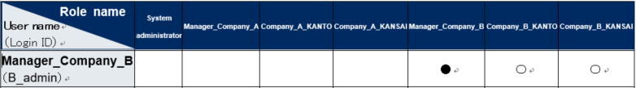The link between user "B_admin" and each role is as follows. (Excerpted from Table 4-1）

**Table 5.1-12 "Table 4-1" Excerpt**

* + - **User name：Company_B_user01**（User ID：B_user01）

If the user is logged in as "B_user01", the following data will be displayed in the "Basic Console" menu group > "Operation list" menu.

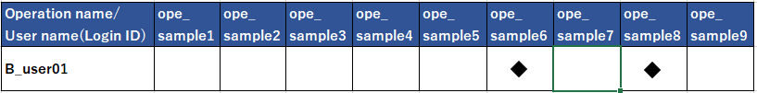

**Table 5.1-13 "Table 5-1" Excerpt**

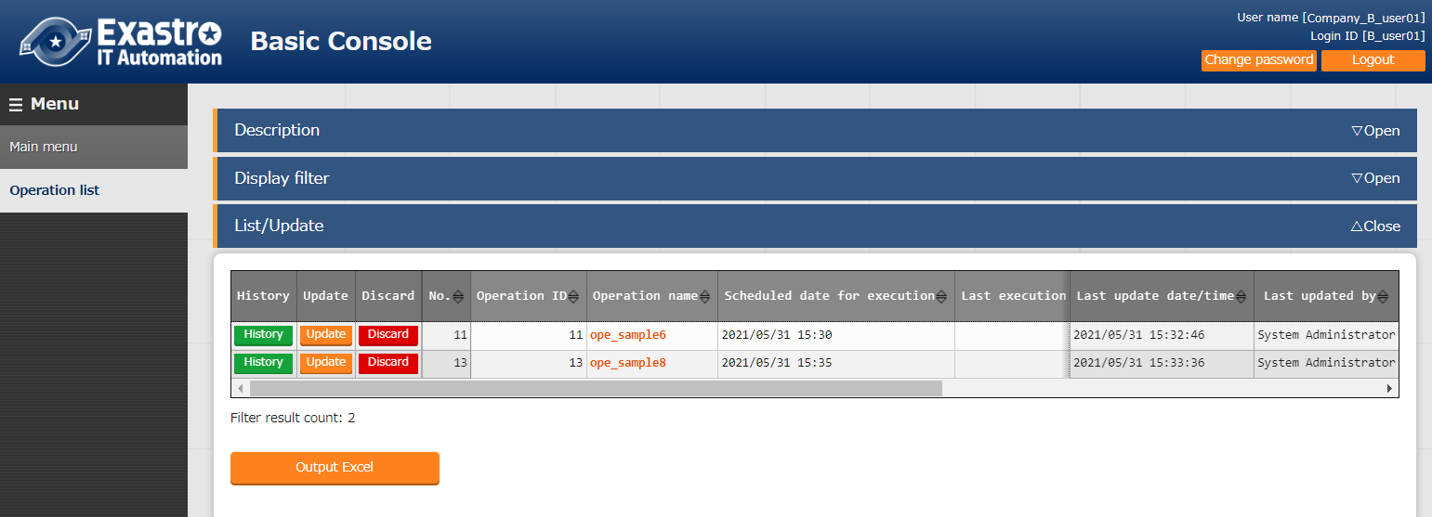

**Figure　5.1-8 List/Update sub menu when logged in as “B_user01”**

The link between user "B_user01" and each role is as follows. (Excerpted from Table 4-1）.

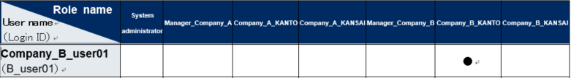

**Table 5.1-14 "Table 4-1" Excerpt**

* + - **User name：Company_B_user02**（User ID：B_user02）

If the user is logged in as "B_user02", the following data will be displayed in the "Basic Console" menu group > "Operation list" menu.

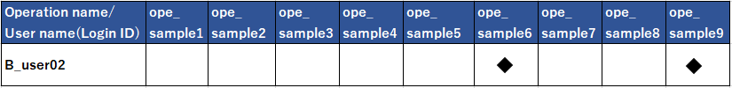

**Table 5.1-15 "Table 4-1" Excerpt**

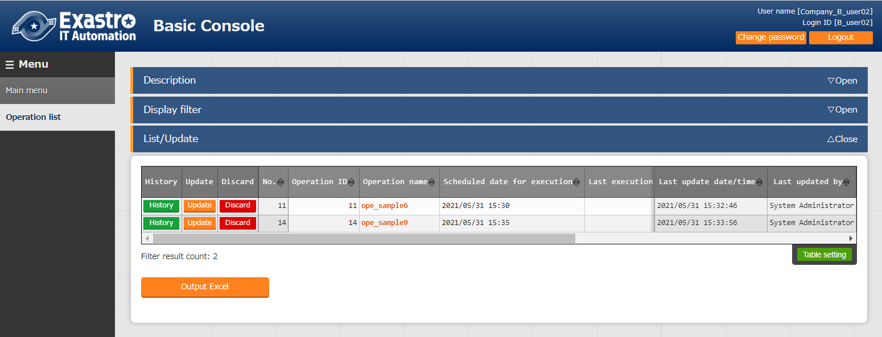

**Figure　5.1-9 List/Update sub menu when logged in as “B_user02”**

The link between user "B_user02" and each role is as follows. (Excerpted from Table 4-1）

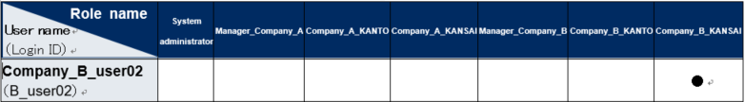

**Table 5.1-16 "Table 4-1" Excerpt**

* + - **User name：Company_B_user03**（User ID：B_user03）

If the user is logged in as "B_user03", the following data will be displayed in the "Basic Console" menu group > "Operation list" menu.

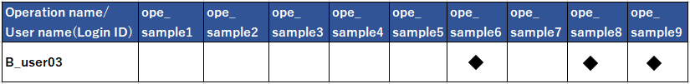

**Table 5.1-17 "Table 5-1" Excerpt**

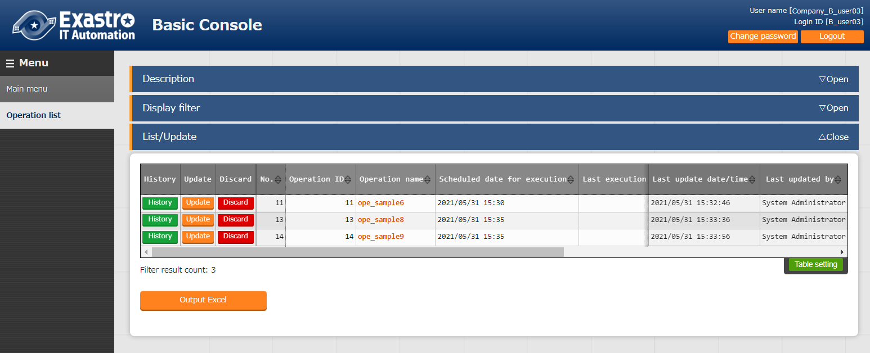

**Figure　5.1-10 List/Update sub menu** **when logged in as “B_user03”**

The link between user "B_user03" and each role is as follows. (Excerpted from Table 4-1）

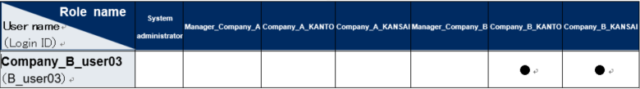

**Table 5.1-18 "Table 4-1" Excerpt**

## Trace history

Only the data will be displayed in the "List/Update" sub menu can also be displayed in the "Trace History" sub menu. Also, the history will be assigned the access permission role.

Example) If the user is logged in as "B_user02".

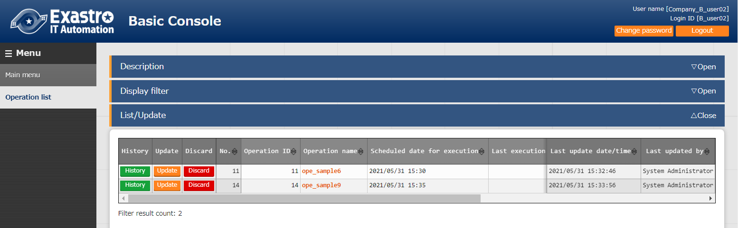The data will be displayed in the "List/Update" sub menu (Operation ID: 6, 9) can be displayed in the "Trace History" sub menu.

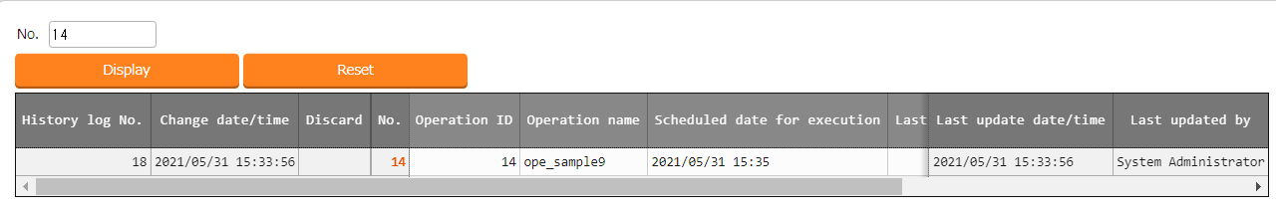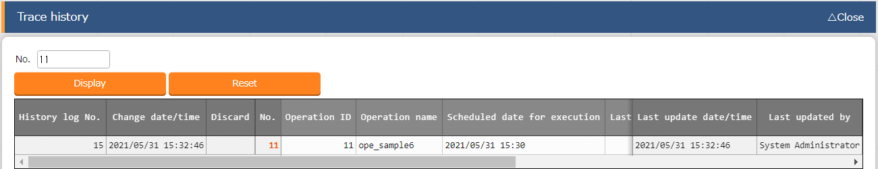

**Figure 5.2-1 "Basic Console" Menu group > "Operation list" Menu".**

Keep in mind that data which users do not have permission to access cannot be displayed. 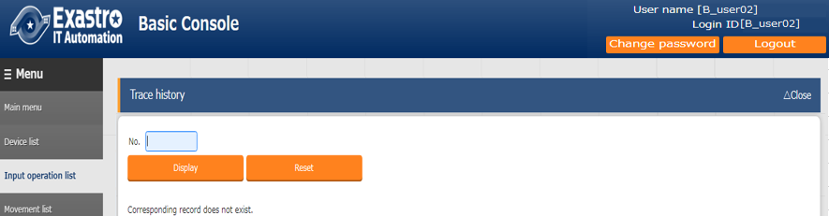

**Figure 5.2-2 "Basic Console" Menu group > "Operation list" Menu".**

The data granted by the role linked to the user in the “Role/User link list” can be viewed in the “Change history” submenu.

Example）Example)If user is logged in as "B_user02".

Roles linked in the "Role/User link list" menu of user "B_user02".

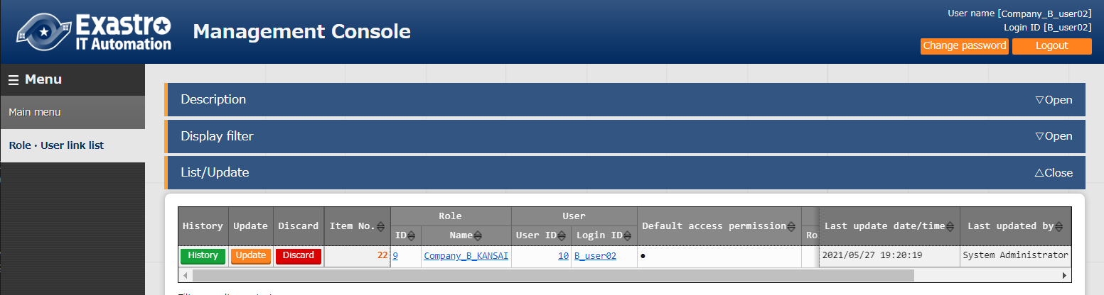

**Figure 5.2-3 "Basic Console" Menu group > "Role/User link list" Menu".**

Data assigned to the role linked in the user's "Role/User link list" Menu".

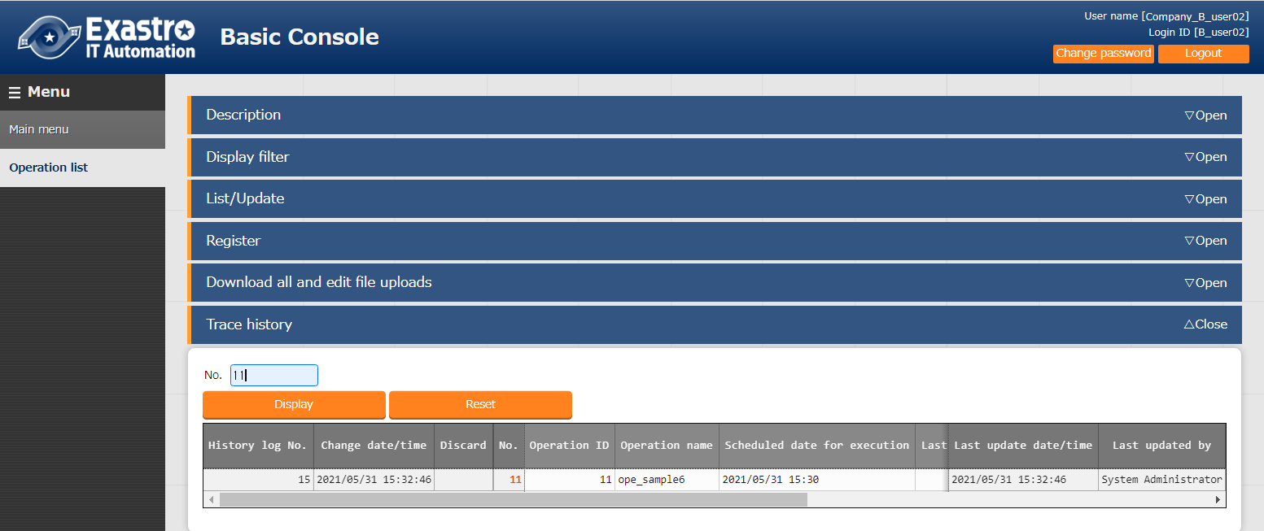

**Figure 5.2-4 "Basic Console" Menu group > "Role/User link list" Menu".**

If a new permission role is granted for the data displayed in the "Trace history" sub menu, data linked with previous roles with different permission roles will not be displayed.

Example) if Data from Company A is passed to Company B.

This section uses the data of user "A_admin" and "B_admin" to explain the permission roles when data is passed from "Company A" to "Company B".

The following figure shows the "Operation list" menu when logged in as "Administrator".

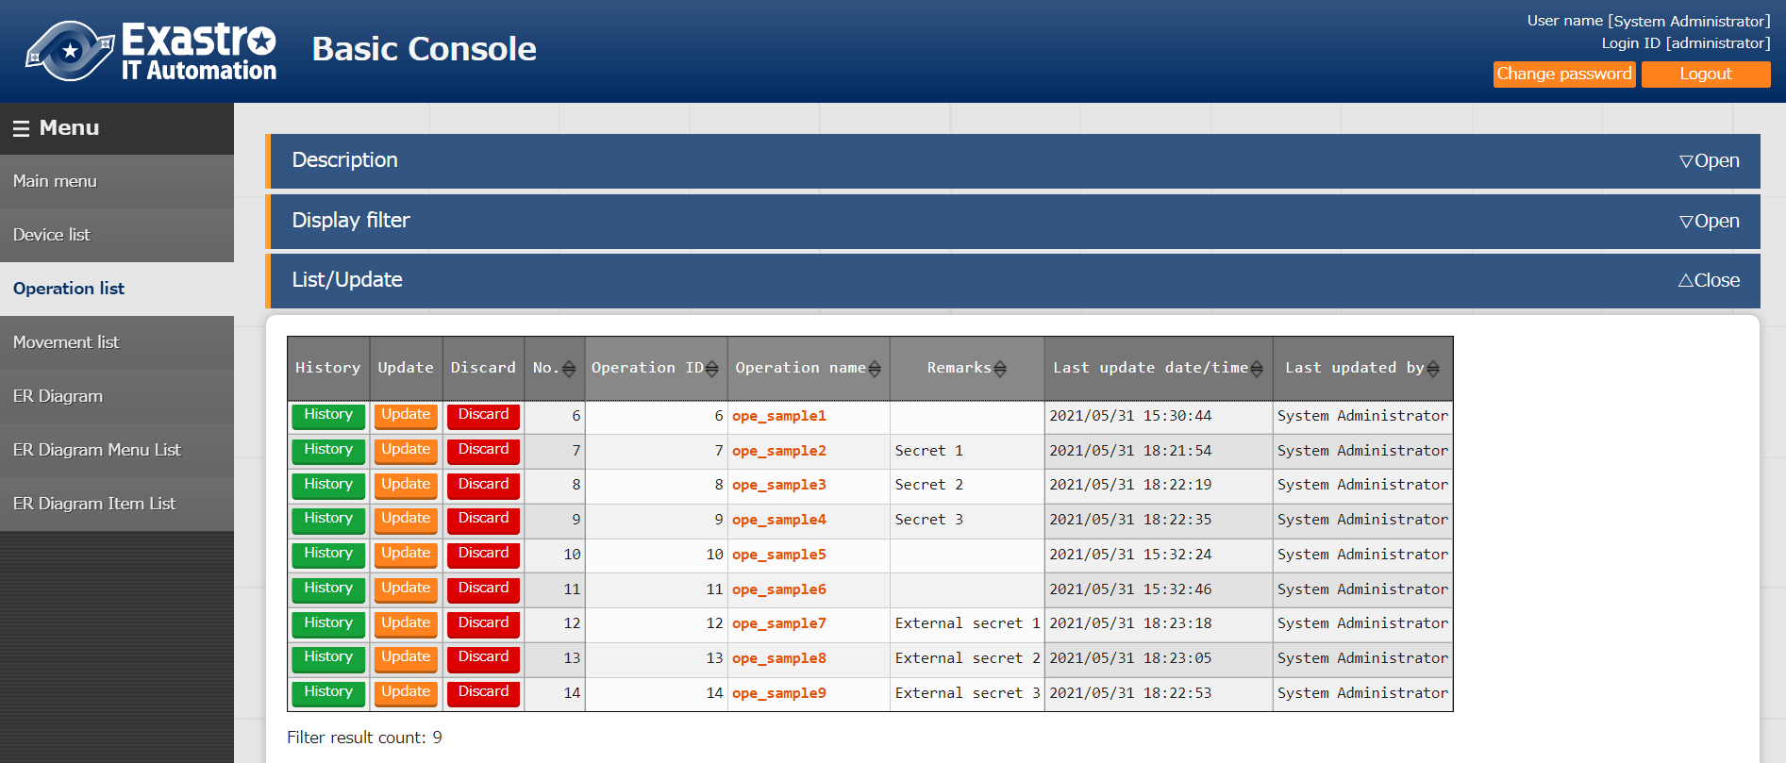

**Figure 5.2-5 "Basic Console" Menu group > "Operation list" Menu"**

We've divided the data into two colors. Data marked with red can be seen by Company A's side (User: A_admin) and data marked with blue can be seen by Company B's side (User: B_admin). (Please refer to figure "A_admin" and "B_admin" for the respective displays when logging in as User "Figure 5.1-4" and "Figure 5.1-8".）respectively.

Additionally, "Top Secret 1-3" and "External secret 1-3" are registered in the "Remarks" Column as information that you do not want to be seen by other roles.

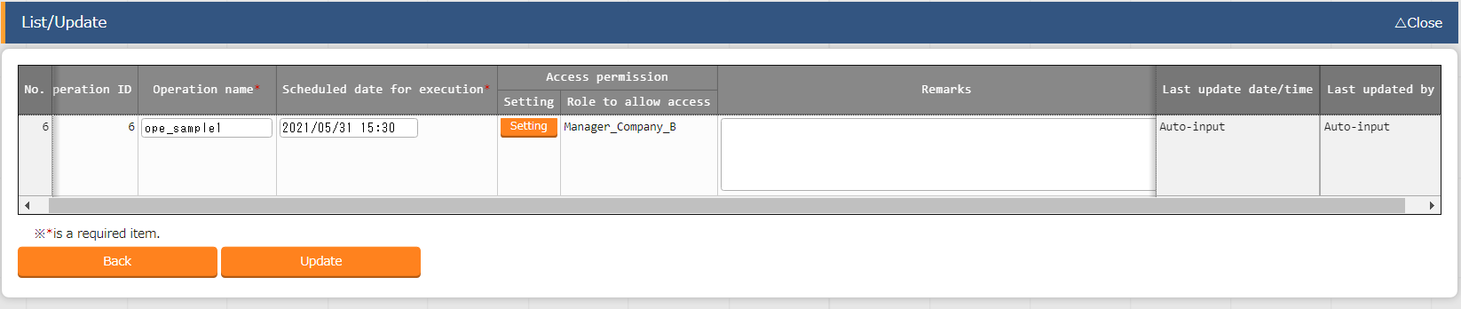The next assumes a case where Company_A delivers data to Company_B. First, delete Secret 1~3 from Company_A’s side and then Change the operation 1, 2, 3, 4’s Access permission role to “Manager_Company_B”.

**Figure 5.2-6 "Basic Console" Menu group > "Operation list" Menu"**

If the user logs out as "Administrator" and log back in as "B_admin", the "list/update" submenu will show a total of eight operation IDs: ID: 1, 2, 3, 4, 6, 7, 8, 9".

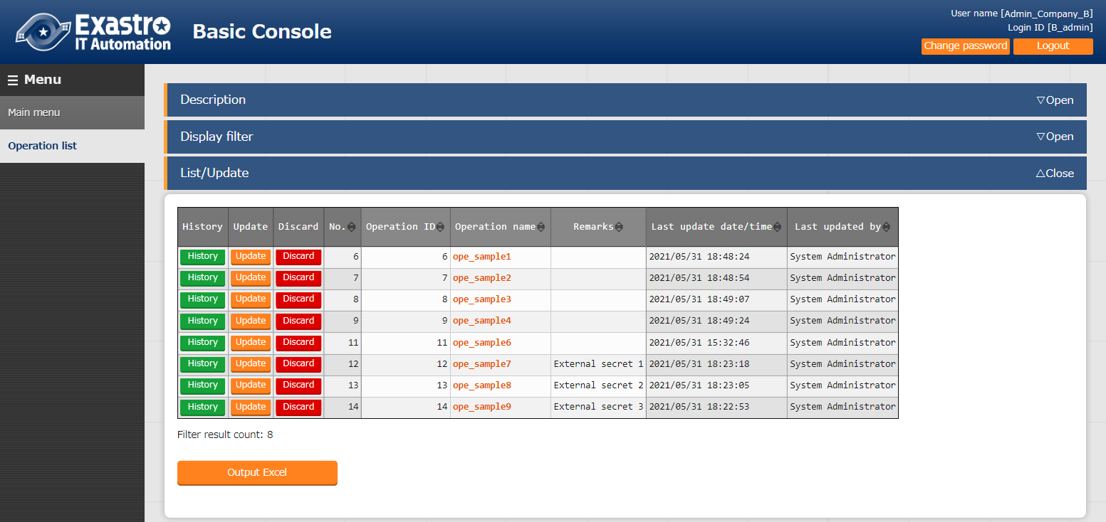

**Figure 5.2-7 "Basic Console" Menu group > "Operation list" Menu"**

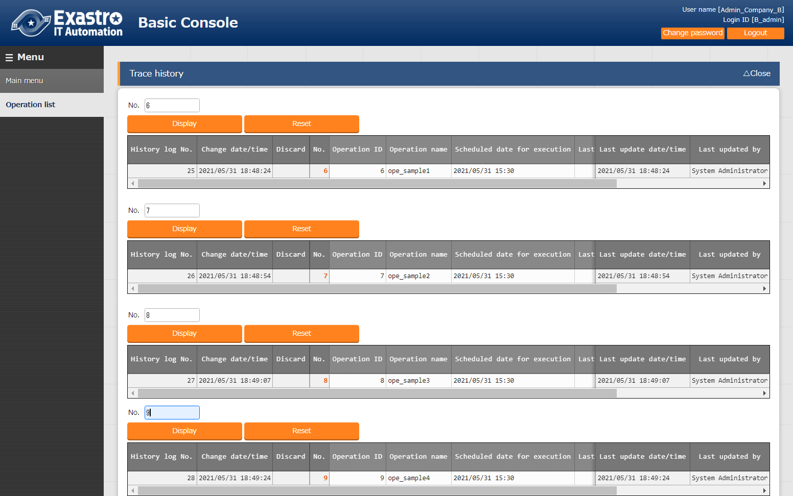If you check the display in the "Trace History" submenu for "Operation ID: 1,2,3,4" where the access permission role was changed, the data linked to different past roles ( Company A Side) will not be displayed.

**Figure 5.2-8 "Basic Console" Menu group > "Operation list" Menu"**For "Operation ID: 1, 2, 3, 4, 7, 8, 9" rewrite the remarks column to "Confidential 1~7".

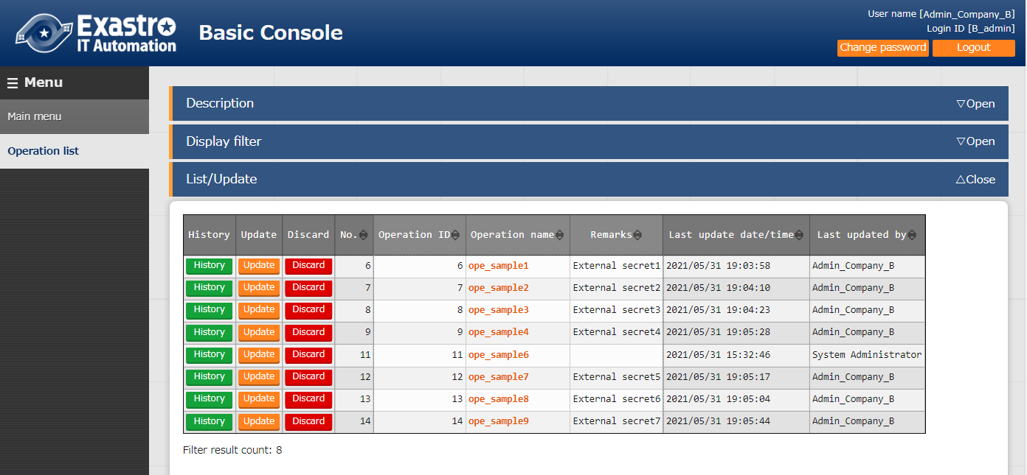

**Figure 5.2-9 "Basic Console" Menu group > "Operation list" Menu"**

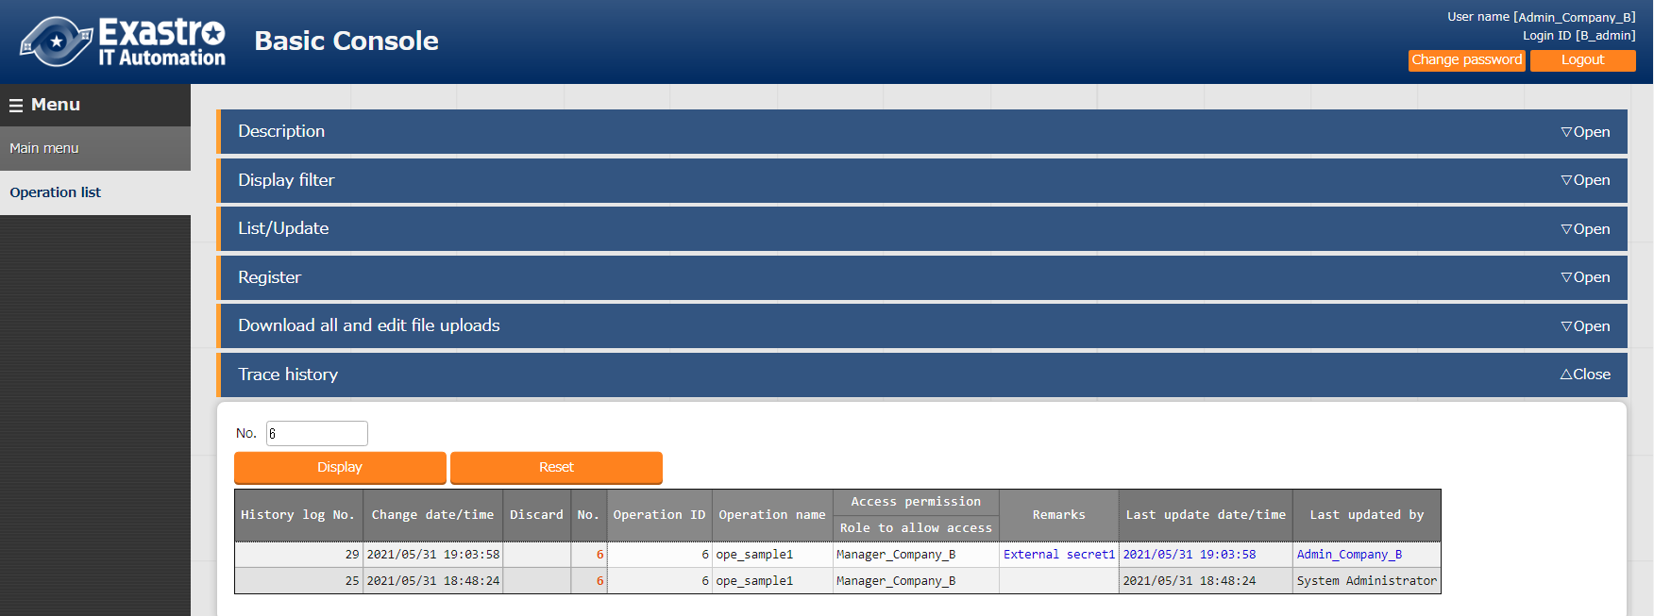As a result of specifying the data of "Operation ID: 2" in the "Trace History" submenu, the "Top Secret 1" registered when the role was "Company A Side" will not be displayed, and only the "External Secret 2" registered this time will be displayed.

o

**Figure 5.2-10 "Basic Console" Menu group > "Operation list" Menu"**

## Display filter

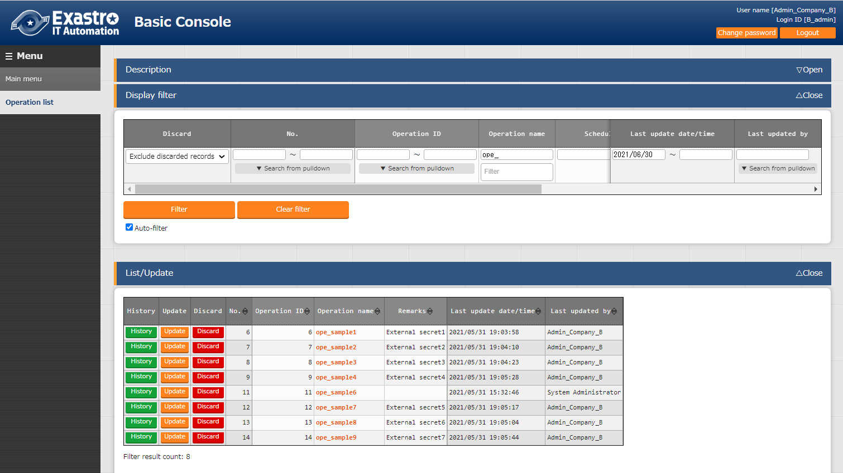Only the data displayed in the "List/Update" sub menu can be narrowed down by the "Display filter" sub menu.

**Figure 5.3-1 List/Update sub menu when the "Filter" button is pressed in user "administrator"**

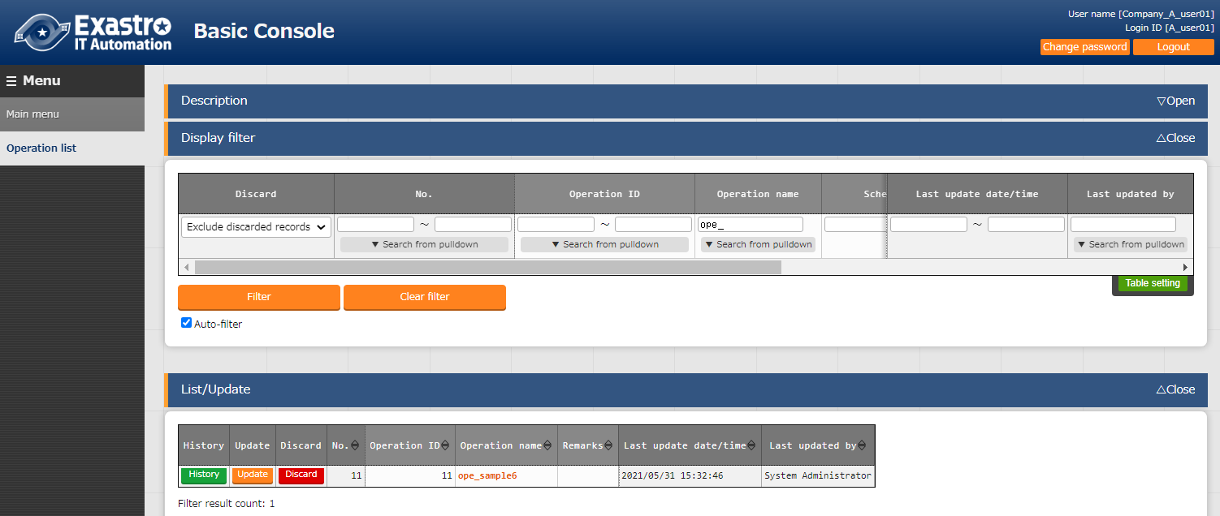

**Figure 5.3-2 List/Update sub menu when the "Filter" button is pressed as user "A_user01"**

In the "Access permission" column of the "Display filter" sub menu, users can search in the following pattern.

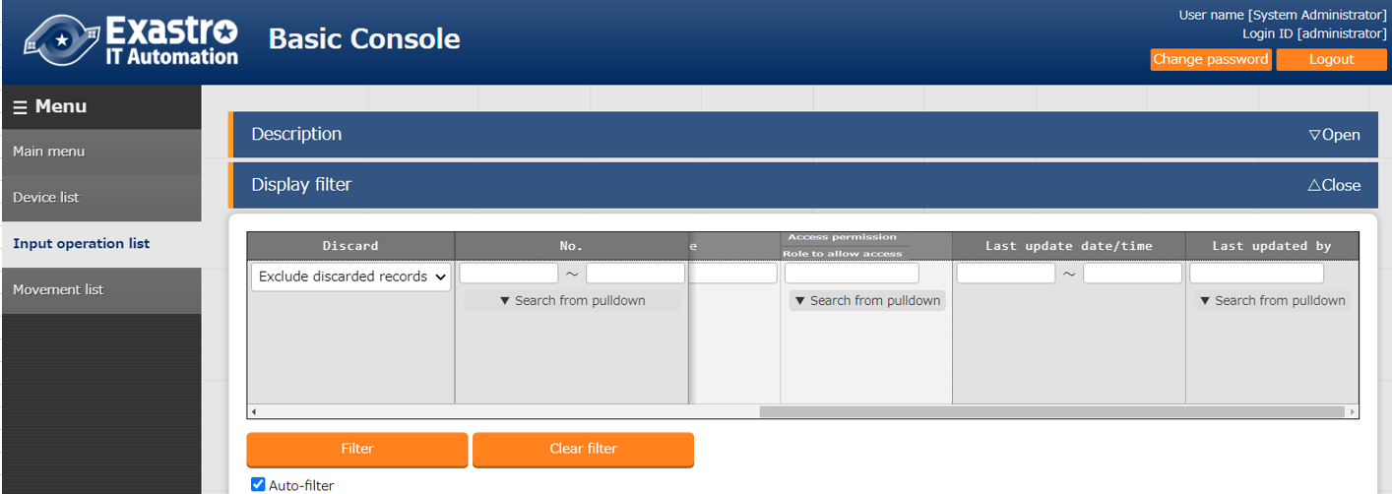

**Figure 5.3-3 "Basic Console" Menu group > "Operation list" Menu"**

**Table 5.3-1 Search pattern**

|  |  |
| --- | --- |
| **No.** | **Pattern** |
| **1** | Search by single selection in the pull-down menu |
| **2** | Search by multiple selection in the pull-down menu |
| **3** | Search by “{blank}” single selection in the pull-down menu |
| **4** | Search by selecting “{blank}” and others in the pull-down menu |
| **5** | Fuzzy search with keywords in string input |
| **6** | Search by entering a real role name in the string input |
| **7** | Search for multiple role names separated by commas in string input. |

Keep in mind that if a comma is used in the string input field as a pattern that cannot be searched for, fuzzy search cannot be performed.

The search patterns no.1 - 7 are explained in detail in the next section.

1. Search by single selection in the pull-down menu

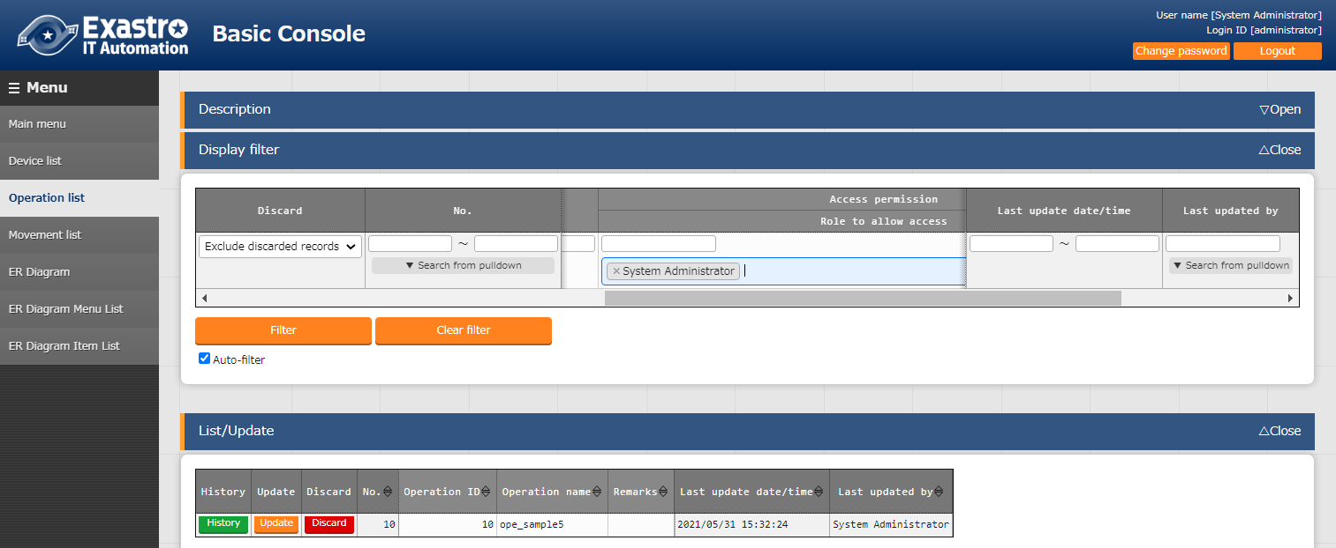Example）Search results obtained by logging in as "Administrator" and selecting the access permission role " System administrator" in the pull-down menu of the "Access permission" column.

**Figure 5.3-4 “Basic console” Menu group > “Operation list” Menu**

1. Search by multiple selection in the pull-down menu

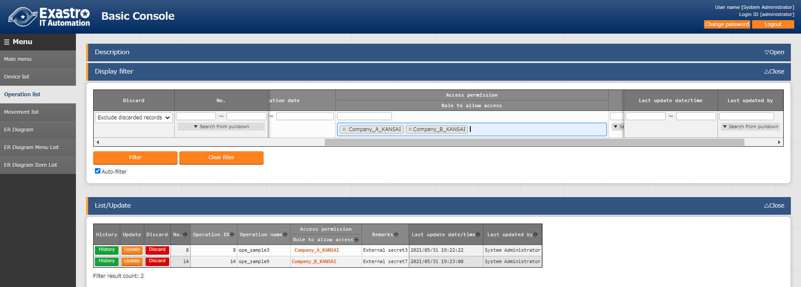Example）Search results obtained by logging in as "Administrator" and selecting the access permission role " Company_A_KANSAI” and “B Kansai Department" in the pull-down menu of the "Access permission" column.

**Figure 5.3-5 “Basic console” Menu group > “Operation list” Menu**

1. Search by “Blank” single selection in the pull-down menu

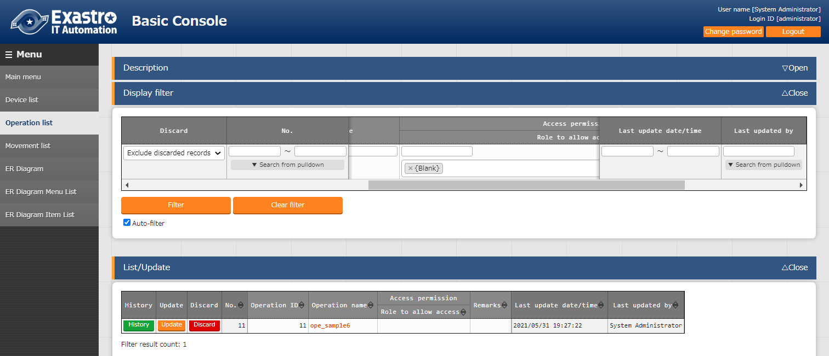Example）Search results obtained by logging in as "Administrator" and selecting the access permission role "{blank}" in the pull-down menu of the "Access permission" column.

**Figure 5.3-6 “Basic console” Menu group > “Operation list” Menu**

1. Search by "Blank" and other multiple selection in the pull-down menu

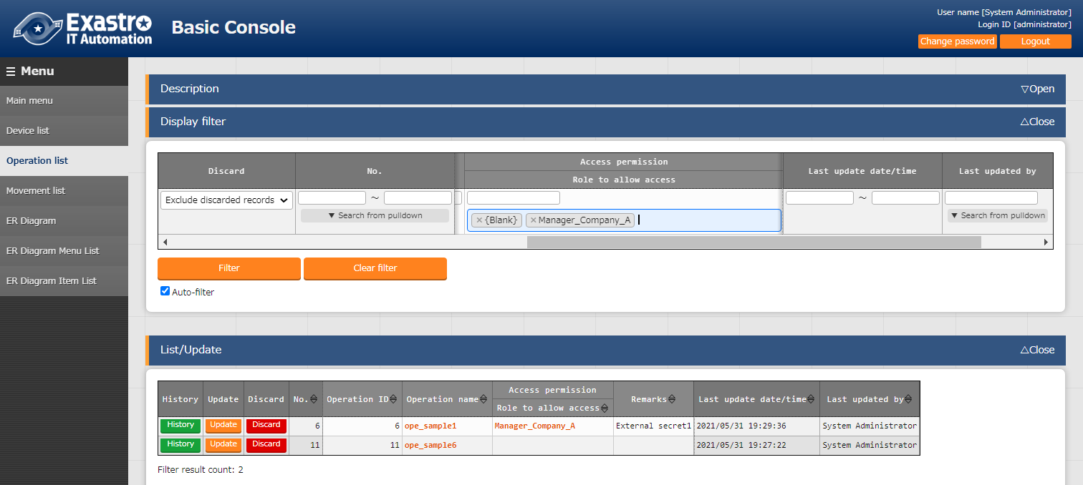Search results obtained by logging in as "Administrator" and selecting the access permission role "{blank}" and “Manager_Company_Aistrator” in the pull-down menu of the "Access permission" column.

**Figure 5.3-7 “Basic console” Menu group > “Operation list” Menu**

1. Fuzzy search with keywords in string input

Example) Search results when user is logged in as Administrator and entered the keyword "Manager" as a string line in the "Access permission" field.

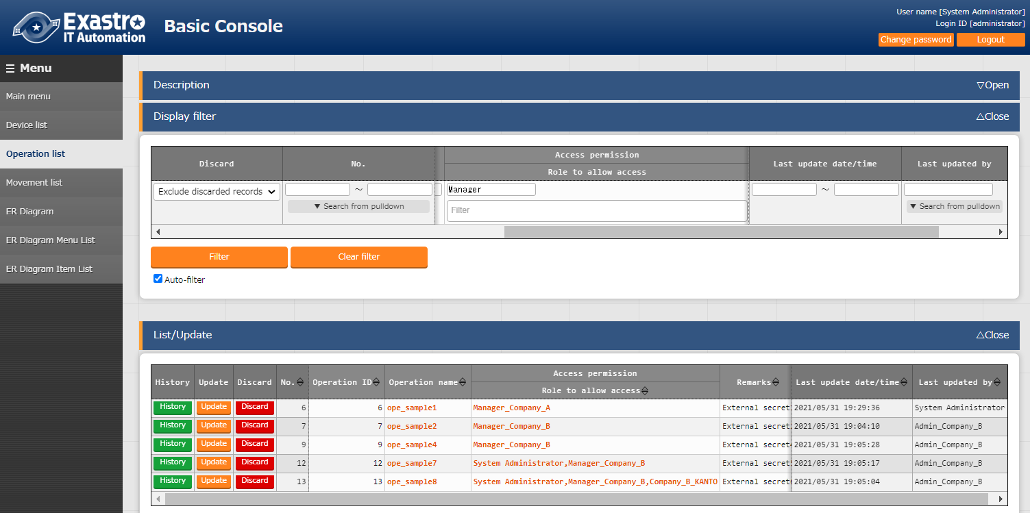

**Figure 5.3-8 “Basic console” Menu group > “Operation list” Menu**

※Fuzzy search is not possible when comma is used.

1. Search by entering a real role name in the string input

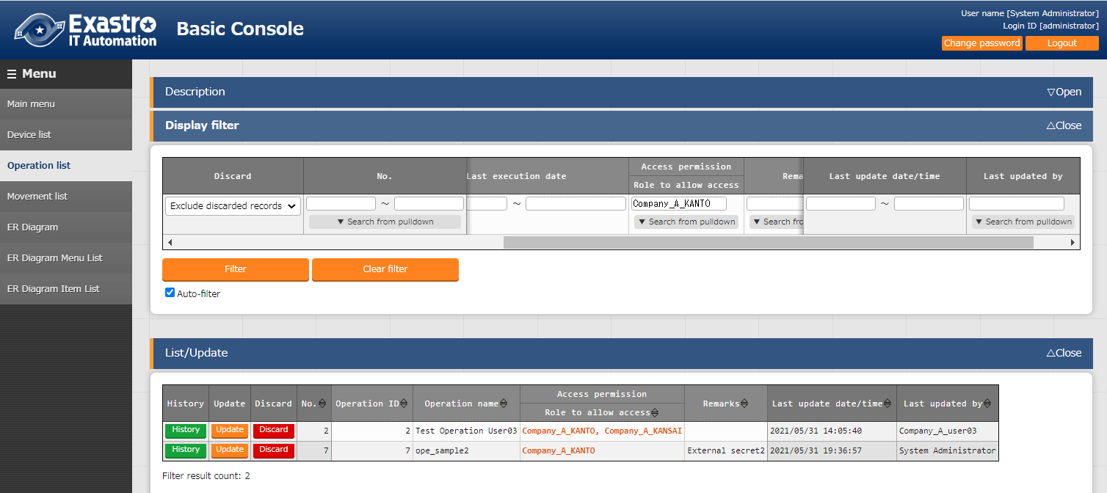Example) Search results when user is logged in as Administrator and entered the keyword "Company_A_KANTO" as a string line in the "Access permission" field.

**Figure 5.3-9 “Basic console” Menu group > “Operation list” Menu**

1. Search for multiple role names separated by commas in string input

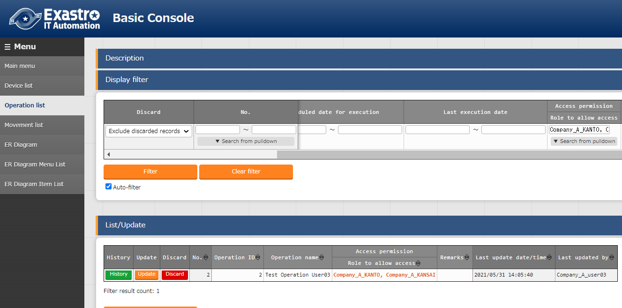Example) Search results when user is logged in as Administrator and entered the keyword "Company_A_KANTO, Company_A_KANSAI" as a string line in the "Access permission" field.

**Figure 5.3-10 “Basic console” Menu group > “Operation list” Menu**

※If multiple entries are entered and separated by commas, the search might not be able to finish depending on the order it was entered.



## RestAPI display filter

This next section explains how to handle permission roles in RestAPI's Filter (X-Command).

There are three types of filters for each column of FILTER (X-Command).

**Table 5.4-1 Filter type**

|  |  |
| --- | --- |
| **Type of files** | **Details** |
| **NORMAL** | Normal fuzzy search |
| **RANGE** | OR search for roles specified in START and END |
| **LIST** | Search by multiple exact match conditions |

The filter pattern is further separated into the following conditions.

**Table 5.4-2 Number of role names**

|  |  |
| --- | --- |
| **Number of role names** | |
| **A** | 1pice |
| **B** | Multiple |

**Table 5.4-3 Search pattern**

|  |  |
| --- | --- |
| **Search pattern** | |
| **a** | fuzzy search for fuzzy role names |
| **b** | fuzzy search for exactly matched role names |
| **c** | Search for role names by exact match |

Using the combination above, this section explains how to handle the permission roles in each filter.

The configuration of the RESTAPI is shown in "Figure 5.4-1" below.

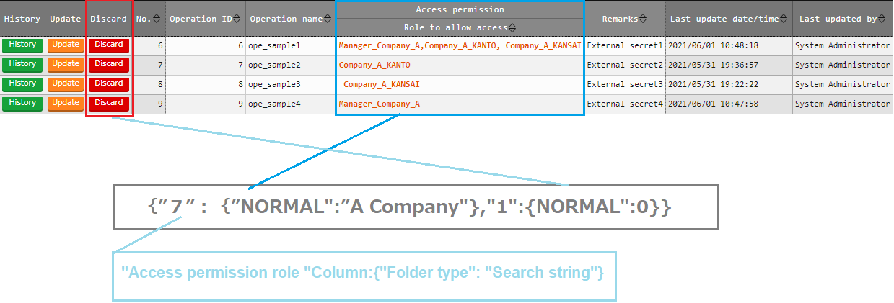

**Figure 5.4-1 RestAPI configuration**

This section assumes that the information in the red frame bellow is added to the registration information "Table 5-1".

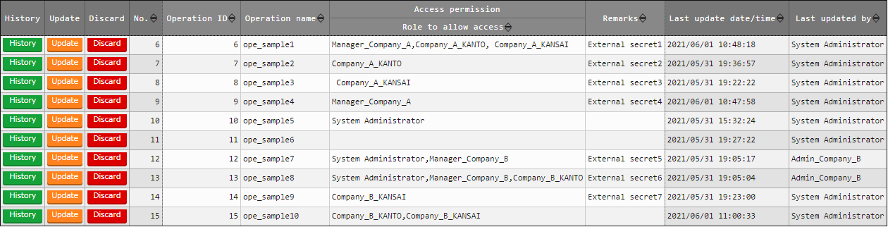

**Figure 5.4-2 “Basic console” Menu group > “Operation list” Menu**

##### **NORMAL**

1. When there is 1 role name
   1. Fuzzy search for Fuzzy role name

{“7":{"NORMAL":"Company_A"},"1":{"NORMAL":0}}

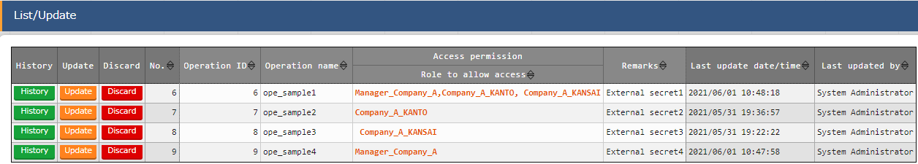

**Figure 5.4-3 “Basic console” Menu group > “Operation list” Menu**

* 1. Fuzzy search for exactly matched role names

{“7":{"NORMAL":"Company_A_KANTO "},"1":{"NORMAL":0}}"



**Figure 5.4-4 “Basic console” Menu group > “Operation list” Menu**

1. When there is multiple role names
2. Fuzzy search for exactly matched role names  
   （Applicable）

{"7":{"NORMAL":" Company_A_KANTO, Company_A_KANSAI "},"1":{"NORMAL":0}}



**Figure 5.4-5 “Basic console” Menu group > “Operation list” Menu**

1. Fuzzy search for exactly matched role names  
   （Not applicable）

{"7":{"NORMAL":"Company_A, Company_A_KANSAI "},"1":{"NORMAL":0}}

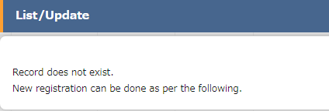

**Figure 5.4-6 “Basic console” Menu group > “Operation list” Menu**

##### **RANGE**

1. When there is role name
2. Fuzzy search for fuzzy role name

{7":{"RANGE":{"START":"Company_A","END":"Company_B"}},"1":{"NORMAL":0}}"

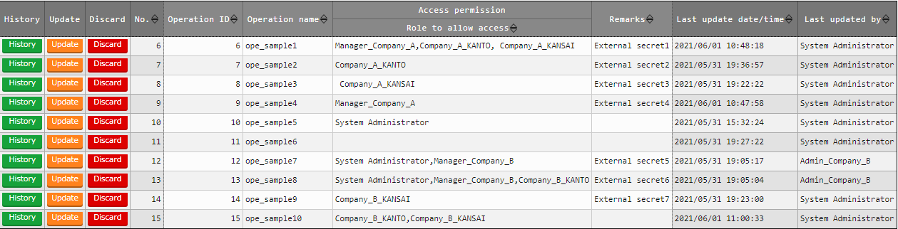

**Figure 5.4-7 “Basic console” Menu group > “Operation list” Menu**

1. Fuzzy search for exactly matched role names

{7":{"RANGE":{"START":" Company_A_KANTO ","END":"Company_B_KANTO "}},"1":{"NORMAL":0}}"

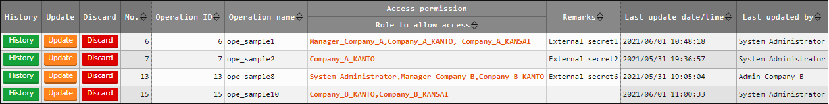

**Figure 5.4-8 “Basic console” Menu group > “Operation list” Menu**

1. When there is multiples role names
2. Fuzzy search for exactly matched role names

（Applicable）

{7":{"RANGE":{"START":"Company_A_KANTO, Company_A_KANSAI,"END":"Company_B_KANTO,Company_B_KANSAI "}},"1":{"NORMAL":0}}"

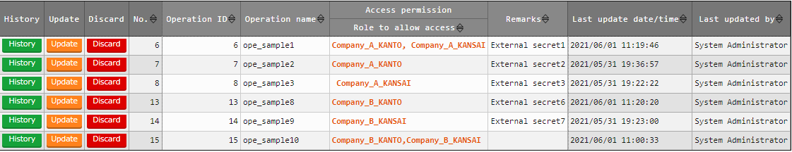

**Figure 5.4-9 “Basic console” Menu group > “Operation list” Menu**

1. Fuzzy search for exactly matched role names

（Not applicable）

{7":{"RANGE":{"START":"Company_A, Company_A_KANSAI","END":"Company_B,Company_B_KANSAI"}},"1":{"NORMAL":0}}"

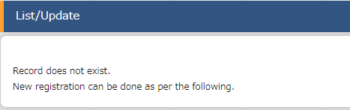

**Figure 5.4-10 “Basic console” Menu group > “Operation list” Menu**

##### **LIST**

1. When there is 1 role name
2. Search exact role names by exact match

（Applicable）

{7":{"LIST":["Company_A_KANTO"],"1":{"NORMAL":0}}}"



**Figure 5.4-11 “Basic console” Menu group > “Operation list” Menu**

1. Search exact role names by exact match

（Not applicable）



{7":{"LIST":["Company_A"],"1":{"NORMAL":0}}}"

**Figure 5.4-12 “Basic console” Menu group > “Operation list” Menu**

1. When there is multiple role names
2. Search exact role names by exact match

{7":{"LIST":["Company_A_KANTO, Company_A_KANSAI "],"1":{"NORMAL":0}}}"

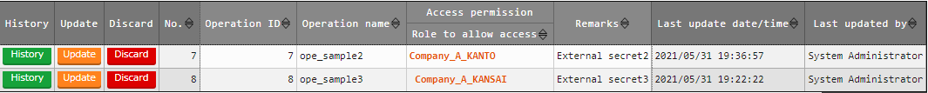

**Figure 5.4-13 “Basic console” Menu group > “Operation list” Menu**